

**UNIVERSITY OF GONDAR**

**FACULITY OF IMFORMATICS**

**DEPARTMENT OF INFORMATION SYSTEMS**

**INSY**: INDUSTRIAL PROJECT

**project title:** DYNAMIC web based APPLICATION FOR univrsity OF GONDAR E- learnig managemet system

**Submitted to:** Department of Information System, in partial fulfillment for the award of Degree of Bachelor Science in information system.

**Prepared By** **ID**

1. ADINA WIBALE GUR/ 0932/06
2. BEZAWIT ALEM GUR / 0996/06
3. MAHILET NIGUS GUR/ 1124/06
4. MENBERE HAILU GUR/1143/06

Project advisor: - PRO.FR.PONNUSAMY

16/06/2017

Gondar, Ethiopia

**Declaration**

This is to declare that this project work is done under the supervision of Instructor PRO.FR.PONNUSAMY, Project advisor, and having the title E-learning Management System for university of Gondar is the sole contribution of

1. ADINA WIBALE GUR/0932/06
2. BEZAWIT ALEM GUR /0996/06
3. MAHILET NIGUS GUR/1124/06
4. MENBERE HAILU GUR/1143/06

No part of the project work has been reproduced illegally (copy and paste) which can be considered as plagiarism. All referenced part has been used to argue the idea and have been cited properly. The project team will be responsible and liable for any consequence if violation of this declaration is proven.

Date: __________________

Group members:

**Full name signature**

1. ADINA WIBALE GUR/ 0932 /06 __________________
2. BEZAWIT ALEM GUR /0996/06 __________________
3. MAHILET NIGUS GUR/1124/06 __________________
4. MENBERE HAILU GUR/1143/06 __________________

Certificate

I certify that this BSC. Industrial project documentation entitled E- learning Management System for university of Gondar.

By:

1. ADINA WIBALE GUR/0932/06
2. BEZAWIT ALEM GUR /0996/06
3. MAHILET NIGUS GUR/ 1124/06
4. MENBERE HAILU GUR/1143/06

is approved by me for submission. I certify further that, to the best of my knowledge, the document represents work carried out by the students.

**Name of Adviser** **Date**  **Signature**

Ins. PRO.FR.PONNUSAMY 16/06/2017 ___________

**Name of coordinator** **Date**  **Signature**

Ins. ASMIRE YEMATA 16/06/2017 ______________

**Examining committee members Signature**

1. _______________
2. ________________
3. ________________
4. _________________
5. __________________

It is approved that this project has been written in compliance with formatting rules laid down by the university.

Acknowledgement

First of all, praise God, the almighty, merciful and adoring, for providing this prospect granting the facility to proceed successfully. The success and final outcome of this project required a lot of guidance and assistance from many people and the team extremely providential to have got this all along the completion of project documentation. Whatever the team has done is only due to such guidance and assistance and would not forget to thank them.

Table of Contents

List of table v

List of figure v

Acronyms vi

Abstract vii

1 CHAPTER ONE 1

1.1 Introduction 1

1.2 Background 2

1.3 Statement of the problem 2

1.4 Objective of the project. 3

1.4.1 General objective 3

1.4.2 Specific objectives 3

1.5 Scope of the project 3

1.6 Limitation of the project 4

1.7 Out of scope 4

1.8 Significance of the project 4

1.9 Target beneficiaries of the system 5

1.10 Feasibility study 5

1.10.1 Technical Feasibility 5

1.10.2 Operational feasibility 5

1.10.3 Economic feasibility 6

1.10.4 Schedule feasibility 7

1.11 Methodologies 7

1.11.1 Data gathering methodology 7

1.11.2 Data modeling technique 7

1.11.3 Analysis methodology 8

1.11.4 Design methodology 8

1.12 Programming tools and database 9

1.12.1 Hardware tools 9

1.12.2 Software tools 9

1.13 Project Cost 10

1.13.1 Software development cost 10

1.14 Project schedule 11

1.15 Work breakdown structure 11

CHAPTER TWO 13

2 SYSTEM ANALYSIS 13

2.1 Existing System Description 13

2.1.1 Problem of the existing system 15

2.2 Requirement Gathering 16

2.2.1 Requirement Gathering Methodologies 16

2.2.2 Data collection method 16

2.2.3 Result Found 17

2.3 Over view of the proposed system 17

2.4 Functional Requirement 18

2.5 Non-functional Requirements 19

2.5.1 User Interface an Human factor 20

2.5.2 Documentation 21

2.5.3 Hardware consideration 21

2.5.4 Performance character 21

2.5.5 Error handling and extreme conditions 21

2.5.6 Quality issue 21

2.5.7 System modification 21

2.5.8 Physical environment 22

2.5.9 Security issue 22

2.5.10 Resource issue 22

2.6 Business rule 22

2.7 System model 23

2.7.1 Scenario 23

Use case model 25

2.7.2 Proposed system actor identification 25

2.7.3 Use cases 25

2.7.4 Description of use case diagram 26

2.8 Activity Diagram 44

2.9 Object model 51

2.9.1 Data dictionary 51

2.9.2 Class diagram 52

2.10 Dynamic model 53

2.10.1 Sequence diagram 53

2.10.2 State chart diagram 59

2.11 User interface 61

3 CHAPTER THREE 62

3.1 Introduction 62

3.1.1 Design Goals 62

3.2 Current software architecture 63

3.3 Proposed software architecture 63

3.3.1 Overview 63

3.3.2 Subsystem decomposition 64

3.4 Component diagram 65

3.5 Hardware/software mapping 67

3.6 Persistent data management 68

3.7 Access control and security 69

3.8 Detailed Class Diagram 70

3.9 Subsystem services 71

3.10 Packages diagram 72

4 Chapter four 73

4.1 Introduction 73

4.2 Sample code and their screen image 73

4.2.1 Home page 73

4.2.2 Login page 74

4.2.3 Forgot password 79

4.2.4 Profile 83

4.2.5 Upload quiz 93

4.2.6 Upload module/assignment 113

4.3 Test Approach 119

4.3.1 Integration Testing 119

4.3.2 System Testing 120

5 Chapter five 121

5.1 Conclusion and recommendation 121

5.1.1 Conclusion 121

5.1.2 Recommendation 121

Appendix 122

References 124

# List of table

Table 1: Tangible cost 6

Table 2: Software cost 10

Table 3: Project schedule 11

Table 4: Work breakdown 11

Table 5: Login use case description 27

Table 6: Create user account use case description 28

Table 7: Update user account use case description 29

Table 8: Change Password use case description 30

Table 9: Delete user account use case description 31

Table 10: Recover forgotten password use case description 32

Table 11: Upload quiz use case description 33

Table 12: Upload assignment use case description 34

Table 13: Upload course material use case description 35

Table 14: Assignment submission use case description 36

Table 15: Take quiz use case description 37

Table 16: Download learning materials use case description 38

Table 17: Discuss in forum use case description 39

Table 18: Display result use case description 40

Table 19: View course information use case description 41

Table 20: Register course use case description 42

Table 21: download e-book use case description 43

Table 22: Assign instructor use case description 44

Table 23: Data dictionary for student 51

Table 24: Data dictionary for instructor 51

Table 25: Data dictionary for system admin 51

Table 26: Table of access control and security 69

# List of figure

Figure 1: Work breakdown structures 12

Figure 2: Activity diagram for login 44

Figure 3: Activity diagram for change password 45

Figure 4: Activity diagram for create account 46

Figure 5: Activity diagram for take quiz 47

Figure 6: activity diagram for upload quiz 48

Figure 7: Activity diagram for upload learning material 49

Figure 8: Activity diagram for download e-book 50

Figure 9: Class diagram for e-learning management system 52

Figure 10: Sequence diagram for change password 53

Figure 11: Sequence diagram for login 54

Figure 12: Sequence diagram for upload quiz 55

Figure 13: Sequence diagram for upload materials 56

Figure 14: Sequence diagram for taking quiz 57

Figure 15: Sequence diagram for register course 58

Figure 16: Sequence diagram for view course information 58

Figure 17: State diagram for login 59

Figure 18: State diagram for take quiz 59

Figure 19: State diagram for discussion forum 60

Figure 20: State diagram for upload material 60

Figure 21 : Home page for proposed system 61

Figure 22: Login page for proposed system 61

Figure 23: Software architecture for proposed system 63

Figure 24: E- Learning management system decomposition 65

Figure 25: Component diagram for proposed system 66

Figure 26: Deployment diagram for proposed system 67

Figure 27: Persistent data diagram for e-learning management system 68

Figure 28: Detailed class diagram for e-learning management system 70

Figure 29: Package diagram for proposed system 72

Figure 30: Home page of e-learning management system 73

Figure 31: Login page 74

Figure 32: Forgot password for users 80

Figure 33: Profile page for student 83

Figure 34: Upload quiz 93

Figure 35: Add question to quiz. 95

Figure 36: Upload module page 113

Figure 37: Student continues assessment result posted on the notice board 124

# 

# Acronyms

1. DB: Database
2. DBMS: Database Management System
3. FOI: Faculty Of Informatics
4. HTML: Hyper Text Markup Language
5. ID: Identification Number.
6. LMS: Learning Management System
7. My SQL: Structural Query Language
8. OODBMS: Object Oriented Database Management System
9. PHP: Hypertext Preprocessing.
10. UML: Unified Modeling Language
11. UI: User Interface
12. UOG: University Of Gondar

.

# Abstract

This project is a part of the industrial project for the fulfillment of bachelor degree in Information System. The project focuses on developing a web based application of E-learning management system for university of Gondar. University of Gondar has its own e-learning system but it is not applicable at this time. The university ICT center needs some improvement in its system. In this paper we try to describe how manual system will be changed to the new computerized system. The current system, which was manual, faced with numerous problems like missing to record the entire daily task, tedious paper work, huge storage space and the like. The proposed system will overcome the problems of the manual system and bring a better working environment. It will provide for users a simple and efficient way of university of Gondar learning management system. The users of this system access the service of the system. We will use the object oriented software development methodology to conduct this project, the programming language is PHP and HTML and the data repository is MYSQL server. This proposed system will bring a change on the way currently learning management system.

# 

# CHAPTER ONE

## Introduction

E-Learning is a term that means something different to almost everyone who uses it. Some use the term to refer to packaged content pieces and others to technical infrastructures. Some think only of web-based self-study while others realize eLearning can encompass real-time learning and collaboration. Almost all agree that eLearning is of strategic importance. Almost all also agree that eLearning is an effective method that should be blended into a corporation’s current learning mix [1].

E-learning management system provides an instructor with a way to create and deliver content, monitor student participation, and assess student performance. University of Gondar uses manual learning management system. In this system the instructors give any learning materials manually. This kind of system has its own negative impact on the students and the instructors as a whole. The impacts include students are unable to get learning materials from the instructors easily and any time they want. Students are unable to get information easily from the department, college and university like exam schedule and other posted information. So, we are motivated to develop a new web based application that solves the current problems.

With the emerging need of digitized systems in every field of life since we are moving into a technology advanced era there is a need of time to have a system that can reduce and insure effective and efficient performance. We want to build software that makes things better, avoiding the problems and add e-library feature which is not included in the university of Gondar e-learning system. Our software will provide online login system for students, online login system for department, online quizzes system that handle three question format that are true /false, multiple choices, matching, and automated evaluation of quizzes, online assignment submissions, and online record retrieval for students and give suitable link to access other e-book site to download books.

This proposed system is more easy and reliable to use than manual system. There is a security system with password in the system that the manual system never had and provides privacy to each student of their records and security of quizzes papers. There are different web forms and tables of SQL Server for every record. It provides also the feature to update the students about upcoming events which can be handled by the administration.

## Background

University of Gondar is one of the thirty-three Ethiopian universities; it was initially established in 1954 as a Public Health College and Training Center (PHC & TC). The basic reason for its initial establishment was the then prevailing health and related problems in and around Gondar. This marks the beginning today’s University of Gondar which still kept the legacy of its predecessors in standing for serving the surrounding community through its education, research and community services.

The university now has ten academic units namely the College of medicine and health Sciences, Faculty of Business and Economics, Faculty of Social Sciences and Humanities, College of Natural and Computational Sciences, Faculty of Veterinary Medicine, School of Law, Faculty of Agriculture, faculty of informatics, School of Technology and School of Education. Currently, the University offers about 57 undergraduate and 61 post graduates in the regular programs. In addition, extension, summer and distance programs are offered by most of the schools, faculties and the college. Recently, the university has launched two PhD programs; one in collaboration with Addis Continental Institute of Public Health. [2]

## Statement of the problem

The project team mainly investigate some problems on the current operation, these are:

* Students are unable to get learning materials from the instructors easily and any time they want.
* It’s difficult to get exam result on time.
* It is time and resource consuming, there by diminishing much of the budget allocated for the departments.
* Lack of privacy to each student of their records and security of quizzes papers.
* Assignments and test papers may be lost.
* During evaluation of assignment and exams it may occurs mistakes.

## Objective of the project.

### General objective

The general objective of the project is to develop online learning management system for UOG.

### Specific objectives

In order to achieve the general objective of the project the following specific objectives are formulated:-

* To Gather requirements by using interview, observation and document analysis that are used for understanding the existing system problems and developing e-learning management system for university of Gondar.
* To analysis the existing system problems by using different methodologies and analysis the e-learning management system by constructing UML diagrams.
* To design and develop the data model, database and user friendly interface of the e-learning management system for university of Gondar.
* Implement and testing the functionality of e-learning management system for university of Gondar.

## Scope of the project

Generally the scope of this project concerns with only e-learning management system for University of Gondar. Tasks that can be includes in this project are

* Instructors can upload learning materials like assignment documents, handout.
* Students can preview and download the assignment documents, complete it and then submit it online.
* Instructors upload objective quiz questions online.
* The system can be marked online through automated marking system and display the result.
* The time and deadline for submission of assignment and quiz will be handled.
* This system contain discussion forum for student exchange to offer more flexible, meaningful and globalized learning experience and knowledge.
* The administrator register course and create student and teacher account.
* The system is accessible only in the campus compound because of using intranet network because of security.
* Students can view about posted information.
* Student can download books that are not uploaded by instructors through the given link to connect to other integrated e-library system through API or link.
* The system admin assign instructor, discussion categories.

## Limitation of the project

* Some software versions were not compatible.
* During requirement analysis there was a challenge to get information at the right time
* Loss of data due to sudden computer system failure.

## Out of scope

* Notifications are not send to SMS and e-mail.
* This system couldn’t upload video and audio files.
* Because of shortage of time the system doesn’t provide video conference.

## Significance of the project

The project has a lot of significant to the university society.

* The proposed system store data in reliable ways that means all data’s are permanently stored in the database for reducing loss of data.
* Reduce the amount of resources that are wasted. The proposed system reduces the amount of papers and other learning materials.
* The proposed system keeps users information like student result that are seen by other users in the existing system ,so only authorized user access its information.
* Easy to search and retrieve of the required users data or information i.e. it saves time.
* Give work satisfaction for instructors as well as for students because the student gets their learning materials and their exam results on time.
* Increases accuracy during exam result in the existing system the instructor might make a mistake. So the proposed system displays the result in accurate way.
* In the proposed system the costs of quiz and exams will be reduced.

## Target beneficiaries of the system

This project provides many benefits for

1. **University**:-in manual there is loss of materials like paper, pen which is cost and needs more man power; the system reduces loss of costly materials and man power.
2. **Student**: - Information processing is very fast and delays can be avoided, it saves a lot of time and the students access the system anywhere and anytime in campus compound when they need. It reduces the tiredness of students by avoiding the going to different stationeries’ to copy handouts.
3. **Instructor**: - It reduces the tiredness of instructors during evaluation of tests and gives result.
4. **Developers of the project**:-It increases our knowledge and gained the skill how developing website and the project team are gets mental satisfaction from the project we developed.

## Feasibility study

What is the important of your system related to the existing working system, explained based on operationally, technically, economically and in Schedule feasibility.

### Technical Feasibility

Most of the technology need for the system has exists in the University of Gondar compound. And also the staff and other concerned bodies will have enough experience using this system. The system is developed by using technologically system development techniques such as PHP, Java script, CSS and MYSQL database which are currently available free to access. The developers select these software’s because we have enough capability to use those technologies to develop the project.

### Operational feasibility

During deployment or run time the proposed system is compatible to university of Gondar network infrastructure. This system will be operated by all users and provides help description to the user about how to use the system. The users friendly interact to the system interface and other technical modification on the system is done by the developers. So that we can say the system is operationally feasible.

### Economic feasibility

As cost/benefit analysis, show the new system will developed using minimum coast and it give a lot of benefits such as advancing the services of the system, decreasing the work load of the users.

**Tangible cost**

|  |  |  |  |  |
| --- | --- | --- | --- | --- |
| No | Name | Quantity | Unit price in birr | Total |
| 1 | Purchase of flash disk (4GB) | 1 | 150.00 | 150.00 birr |
| 2 | Purchase of CD RW | 2 | 20.00 | 40.00 birr |
| 3 | Purchase of stationary paper  Pen  Pencil | 1.5 packet  20  5 | 100.00  3.00  1.50 | 150.00 birr  60.00 birr  7.50 birr |
| 4 | Purchase of CD_R | 4 | 5.00 | 20.00birr |
|  | For print | 100 | 2.00 | 200 birr |
| 5 | Client computer | 1 | 15,000 | 15,000 birr |
| 6 | Total estimate cost | - | - | 15,427.50birr |

Table : Tangible cost

**Cost reduction**

To copy one chapter in single course it takes in minimum single paper takes 0.5 cent.

If one chapter have 20 page it takes=10 birr (0.5*20)

If one course have 6 chapters it takes=60 birr (10*6)

If one batch takes 6 course it takes= 360 birr (60*6) in one semester

If one department have 4 batches the cost increasing to **1,440** birr in one semester for individual person.

In the proposed system the student download learning materials with in a second takes maximum 100 birr for all. So in the newly proposed system the cost that reduced by **1440-100** = **1340 birr** (93%) because this system is web based (i.e. most of the material used in manual system was not used to give the course) and it is use for a long period of time.

**Intangible** **benefit:** are benefits derived the creation of an information system that cannot be easily measured in money.

The intangible benefits of the new system are:

* Increase in accuracy of e-learning management system.
* Faster decision making by searching records from database.
* Increase security by providing authorized user can access.

### Schedule feasibility

A project will fail if it takes too long to be completed before it is useful. Our proposed system will be completed with the given time frame that is stated on page11 table 3.

## Methodologies

### Data gathering methodology

During requirement analysis, data needed for the project will be gathered from various sources. During gathering and collecting necessary data and information needed for e-learning management system analysis, the system use two major fact-finding techniques those are primary source and secondary source.

Primary sources are interview and observation. In secondary source the system obtain data from different document.

* **Interview**

We interview the students and instructors and the ICT center software office employees about existing system learning management system. The interview procedure that we follow is attached in the appendix.

### Data modeling technique

The team members use Object Oriented Database System to develop this system because it is a system development approach encouraging and facilitating software components. The development models are the various processes or methodologies that are being selected for the development of the project depending on the project’s aims and goals. The requirement is known for the developers.

This project involves building an e-learning management system for university of Gondar. In order to achieve our project, an appropriate software design methodology would be chosen iterative data model.

Iterative development is a way of breaking down the software development of a large application into smaller chunks. In [iterative](http://searchsoftwarequality.techtarget.com/definition/iterative) development, feature code is designed, developed and tested in repeated cycles. With each iteration, additional features can be designed, developed and tested until there is a fully functional software application ready to be deployed to customers [3].

Typically iterative development is used in conjunction with incremental development in which a longer software development cycle is split into smaller segments that build upon each other.

We choose this iterative data model because of it:-

* Building and improving the product step by step.
* Can get the reliable user feedback.
* Less time is spent on documenting and more time is given for designing.

### Analysis methodology

After gathering different information from stakeholders we will analyze requirements by using Unified Modeling Language models like use case diagram, sequence diagram and class diagram. Since. [4]

* UML is a modeling language widely used to visualize the object oriented designs.
* UML makes it easy to visualize the software design.
* UML diagrams can be easily decoded and converted into most of the popular object oriented programming languages.

### Design methodology

The project team select object oriented approach to design the system because it has best feature than other approach.

Reduced Maintenance: The primary goal of object-oriented development is the assurance that the system will enjoy a longer life while having far smaller maintenance costs.

Real-World Modeling: Object-oriented systems tend to model the real world in a more complete fashion than do traditional methods.

Improved Reliability and Flexibility**:** Object-oriented system promise to be far more reliable than current systems, primarily because new system can be "built" from existing objects.

## Programming tools and database

**Back-end**: The back end of this project used MYSQL, Apache and PHP because:

* It is more reliable.
* It is easy to use.
* It supports many operating systems

**Front end**: The Front end of this project used HTML, CSS and JavaScript because:-

* They can make effective design easily and substitute
* They use simple programming language
* They can be easily updated or changed

**Programming tools**

There are two types of programming tools. These are hardware tools and software tools.

### Hardware tools

This project used the following hardware tools.

* Laptop Computer: - used to develop the system.
* Flash Disk: - used to store and secure data as backup.
* CD/DVD: - used to store and secure data as backup.

### Software tools

Since, there are many software tools for developing any projects. This system or project uses listed below.

* Code lobster: - to write different codes of the projects. It is important because it support different languages like HTML, PHP, and JavaScript. It also used to run and test the project
* Html:-to display the web page.
* CSS: - for the formatting of the web site.
* JavaScript: - used for validation.
* WAMPSERVER: -this software assists to create database or back end of the system, to run and test system application.
* Note Pad and Note pad++:-It used as reserve code to write this project.
* Microsoft Office window 2010:- used to write documentation part of this project.
* EDRAW Max: - used to design the diagram of the system or project.

## Project Cost

### Software development cost

For this particular project we will be using different software but the software’s are getting from the university.

|  |  |
| --- | --- |
| Software costs | |
| **Software Description** | **Price** |
| Microsoft office word 2010 | Free |
| Microsoft power point 2010 | Free |
| Microsoft SQL server | Free |
| A vast antivirus | Free |
| XAMPP | Free |
| Total | --- |

Table : Software cost

## Project schedule

|  |  |  |  |  |  |  |  |
| --- | --- | --- | --- | --- | --- | --- | --- |
| **Activities** | Time schedule | | | | | | |
| **December** | **January** | **February** | **March** | **April** | **May** | **June** |
| Preparation of project proposal |  |  |  |  |  |  |  |
| Preparation of project analysis |  |  |  |  |  |  |  |
| Preparation of project design |  |  |  |  |  |  |  |
| Implementing |  |  |  |  |  |  |  |
| Testing and maintenance |  |  |  |  |  |  |  |

Table : Project schedule

## Work breakdown structure

The work breakdown structure is a view into the project which shows what work the project encompasses. It is a tool which helps to easily communicate the work and processes involved to execute the project. The Project Manager and project team use the work breakdown structure to develop the project schedule, resource requirements and costs.

|  |  |  |
| --- | --- | --- |
| **ID** | **Tasks** | **Responsibility** |
| 1 | Data Gathering And Project Proposal | All members |
| 2 | Data Gathering And System Analysis | All members |
| 3 | System & Object Design | All members |
| 4 | Implementation And Testing | All members |

Table : Work breakdown

Figure : Work breakdown structures

# CHAPTER TWO

# SYSTEM ANALYSIS

## Existing System Description

The current learning management system of University of Gondar is a labor-intensive system; the current system is time and resource consuming and inefficient. It tries to facilitate learning needs based on the regular way of teaching learning process, there are many methods that used in current learning management system that are.

* **Class room lecture**

This is one of the major ways that the current learning management system uses in order to simplify the learning teaching process. This class room lecture will be taking continuously throughout the given semester. In this way the Instructor (lecturer) and the students must come together to the lecture class with a specified time in order to attain the lecture.

This way of learning management system helps both the Instructor and students to give better interaction in learning process and based on the time given for the semester so that the course can be completely covered. Though it is the main way to reach to our goal of managing a learning process, this method has some limitations.

* There is no other means of communication for the Instructor and students out of the class room so this will delay the ongoing process.
* In the class room the instructor cannot properly reach all the questions that are raised by the students because of limitation of time.
* The main problem of current system is if the Instructor or students are absent, it will be difficult to continue the teaching learning process. Whenever such difficulties arise, it results is being unable to complete the course within specified time schedule, being unable for a timely submission of assignments, projects and so on.
* **Classroom tutorials**

This is an additional way of helping the students. It is the same as classroom lecture. But this one is not obligatory. It helps students to get the idea of the concepts deeply; that may be difficult to understand in only one class room lectures; using tutorial classes are more useful and it plays a great role with regard to affirmative action. But it also has its own drawbacks.

* It is must need that both the Instructor and the students meet in one class; this will be difficult if the Instructor is busy.
* It is time consuming and limited by time.
* **Handout**

This is another yet most important and frequently used way of forwarding learning process. This is a way in which the Instructor periodically gives additional learning materials gathered from many resources in printed form to each student for a particular chapter. In this way the Instructor will help the student to get the essential information in one handout.

But this process has also its own drawback regarding both the Instructors and the students and also the institute.

* It is so tedious for instructors’ to prepare and give handouts in the form of hard copy
* There will be a vast wastage at resource such as paper, toner, manpower and the like.
* It may lead the students to fully depend on the handout and they may never be initiated to refer more.
* **Quiz and test**

This one is another method of facilitating learning process. The instructors give quiz and test to measure students whether they understand the concept of the given course. The instructors give the quiz in one room or separate students based on their group and assigned one teacher to assist this process. But these methods have some impacts that are.

* There will be wastage of resource such as paper, toner, manpower and the like.
* During submission of the quiz or test assessment (result) the paper of the student may be lost.
* During evaluation of the quiz the instructor may make a mistake.
* **Notice Board**

This is the main way of activities between the department and their respective students. Whenever there is information which needs to be posted or delivered to the students. It will be written on a paper (printed on a paper) and it will be posted immediately on the notice board.

Information which will be posted includes:-

* Exam schedule
* Exam result
* Advisor/Advice call
* project / Assignment deadlines
* Emergency notices

Whenever such information is posted the students must see/ hear physically what is posted or essential information may be lost without satisfying their goals, chasing the students/ the department to dissatisfaction.

As mentioned above this method need to be updated periodically and must also be visited by the students continuously. Thus it is

* time consuming
* Resource consuming

### Problem of the existing system

* Students are unable to get learning materials from the instructors easily and any time they want.
* It’s difficult to get exam result on time.
* It is time and resource consuming, there by diminishing much of the budget allocated for the departments.
* Lack of privacy to each student of their records and security of quizzes papers.
* After submission of assignment and test papers it may be lost.
* During evaluation of assignment and exams it may occurs mistakes.

## Requirement Gathering



### Requirement Gathering Methodologies

The system will be developed and implemented using methodologies that involve user friendly and interactive web based program building.

### Data collection method

When we collect the learning management information’s by using different method from different data source. These methods include interview and practical observation.

* **Practical observation:**

Even though interview and questionnaires are important to gather information, practical observation is simple and the group members physically observe information that cannot maintain from the interview or others. Since the group members are the member of this university, we observe teaching and learning process of existing system problems that are stated in the statement of problem that are the result of students are not private that are seen by other users or students. The evidence of observation is attached on appendix.

* **Interview:**

The project team goals are to implement a web based system and to overcome the drawbacks of the manual system. That’s way we have to go through an interview process which will give necessary information about the project requirement and help to solve a problems as well as fulfill in the user requirements. The team use interviews to collect information from individuals or from groups. The interview question that we used to collect necessary information is attached on the appendix.

* **Document analysis**

To have detailed awareness about our project we use documents such as, industrial project paper that are done for four years. During the analysis of documents we gave a special consideration to those documents which can bring features to our system. We use journal of computer science e-Learning Management System Using Service Oriented Architecture authored by Mohammed A. Jabr and Hussein K. Al-Omari to see how to analysis the e-learning management system .Manual of Learning Management System prepared by COMSATS Virtual Campus used to see the interfaces ,forms that are used in the design part. We use MOODLE for teacher, trainer and administrator authored by Free Software Foundation for understanding all concepts about how the proposed e-learning management system features work.

### Result Found

These team members have seen the manual system of learning management system. We used three data modelling technique to identify the problems of existing system which are interviewing, observation and document analysis. So we concluded that:-there are a lot of problems in the existing learning management system that are stated in the statement of problems and because of university of Gondar not use developed system this system needs to be automated.

## Over view of the proposed system

During our observation and interview of users the project team observed certain problems from their manual based system. Because of this the project team proposed to solve the problem of the existing learning system by developing e-learning management system. That means our proposed system will minimize the current problem and weakness of existing system by providing consolidated learning management system, the student can get their learning material only in one site. The proposed system will also provide easily resource controlling mechanism and create communication between instructors and students. The proposed system provides that student can get exam result on time, student can ask that raised from confusion by using this system discussion room, students can get reliable and accurate information and if students need additional books that are not uploaded by instructor student can get books and download by using links connected to other e-book sites.

Students can view and access their course schedules, course descriptions, Online Lectures, assignments, grades, quizzes and many other services. They can also complete online assignments and participate in grouped discussions, moderated discussions.

As generally the proposed system will able to minimize the existing problems and resource consumption because the university teaching and learning activities are based on manual system.

## Functional Requirement

The new system has to perform some the tasks done by the current system without changing the rules and regulation of the current manual system in cost effective way. Due to this fact the input, process and output of each subcomponent of the new system is the same as the existing system. The difference is that the execution time of the process became faster and tasks are executed electronically through computers in order to improve efficiency, capacity and flexibility of the system as compared to the current system in which tasks are executed manually.

In general, the new system is user friendly, which has interactive graphical user interface, which enables user of the system to perform tasks easily and effectively.

**Functional requirements for student**:

* Student can submit the solution of any of his assignments before the deadline (If strict).
* Student can see the information about the assignment (description and instruction, start-time, end time, motivation, how to download and upload the assignment and type of work: individually or as groups).
* Student can see any notices that are uploaded by the system admin and instructor.
* Student can take objective quizzes online.
* Student can get exam result in automatic mechanism.
* Student can raise their idea about a given question by using the system discussion forum.
* Student can preview and download learning materials that are uploaded by instructors.
* Student can find and download other reference books that are not uploaded by instructors by using link to go to e-book sites.

**Functional requirements for teacher:**

* Instructor can upload assignment and its information (description and instruction, start-time, end-time, motivation, how to download the assignment and upload it, type of work: individually or as groups).
* Instructor can upload learning material handout, worksheet, to the students.
* Instructor can see the assignments submitted by students and assess the students by evaluate their results.
* Instructor can see any notices that are uploaded by system admin.
* Instructor can answer the student question and discuss their idea by using discussion forum.
* Instructor uploads quiz question online.

**Functional requirements for system admin:**

* System admin can register student and instructor.
* System admin can manage course that means he/she add course, update course or delete course.
* System admin can manage user account.
* System admin post information that are any new notification exam date and other information.
* System admin can assign instructor and course.
* System admin create discussion categories.

## Non-functional Requirements

Non-functional requirement of proposed system specifies how the system should behave or a non-functional requirement is a statement of how a system must behave, it is a constraint upon the systems behavior. It specifies all the remaining requirements not covered by the functional requirements. They specify criteria that moderator the operation of a system, rather than specific behaviors. Some of the non-functional requirement of this project is listed below.

* **User interface:** These requirements include the qualities of the system that are desirable from the users’ point of view. The new system will use windows type graphical user interface. This type of interface is easy to use for very little additional training and common to most computer users. The system will enable the users to use the system.
* **Usability:** the ease with which a user can learn to operate, prepare inputs for, and interpret outputs of system or component. The system should support ease of use that is it shouldn’t be complex to use. The user interface should be user friendly. Our system contends the help facility for user.
* **Availability:** The system will be available within the university compound to its users, and the system is available any time without maintenance time, since it is web based.
* **Reusability:** The data and record that are saved to the database and shall be reused if needed.
* **Security consideration:** The system allows its user to perform their task only after login process. The user should be attended with the legible account and password otherwise they won’t be allowed. The authority to login to the system is only by the correct ID and password.
* **Good performance:** The system will be capable of carrying huge amount of data with one database and we improve performance by using computers or laptops that have high processor speed and RAM.
* **Fast response time:** The system responses user request quickly to satisfy the user need.
* **System Modification & Maintainability:** The system can be maintained and modified for future use because the scope can be enlarged.
* **Error handling condition:** To reduce input fault, the system will: - Respond to error inputs by asking the user to re-enter data in the correct format.
* **Safety:** The database should be backed up in a reliable secondary storage media. This used to the user to recon problems or data loss problem occurred.
* **Portability:** The software shall be deployed at any web browsing as we are using PHP.

### User Interface an Human factor

The application we are developing is web based and which is for the students, it is not difficult to use it. They are only expected to know basic computer skill and since the application is working over the internet, the users should know at least how to use the internet and to navigate the browsers.

### Documentation

The System has well defined document which helps to easily maintain the system and the project team will also prepare short and precise help file on how to use the system for the system users. It will have a helping page to guide the user of the system and to show the process how they will have to use.

### Hardware consideration

The user of this application can use any computer having any browser. We use the most common database server MYSQL in software tools that is platform independent and WAMPSERVER on the server side so that there is no hardware compatibility problem in using this application.

### Performance character

Since the system is going to be accessed by different users with different needs, it should be capable of handling and processing their queries quickly. Besides the software, Hardware will also be a great factor in the systems’ performance. Generally, the system should be able to handle many users and it will be responsive.

### Error handling and extreme conditions

The system is expected to handle errors encountered during run time. Errors could rise from users and from the system. Errors that occurred from the wrong doing of users will be handled by appropriate exception handling mechanisms. Generally, if an error occurs, the system will identify the error and notify the user so that he/she can take the appropriate corrections rather than terminating the system.

### Quality issue

When the clients are using this application, they may find something, which needs improvement and efficiency, or they may have their own appreciation about the application. So we will provide them with a page to fill it and from the feedback we collect, the system can be improved as they need.

### System modification

The System modification can be achieve easily because the system is going to be designed using an object oriented approach.

### Physical environment

The server must be put on a place that has high security room. And the client must put in the local area it must connect with server.

### Security issue

The system has login page which allows only the users who have privilege to access the system therefore the system can’t be accessed by unauthorized user. When the users want to access the e-learning management system they sign up to the system and sign in to the system. Each system users can access the system based on their access right.

### Resource issue

**Server:** The minimum hardware requirement for MYSQL is-

* CPU: 32 bit or 64 bit
* Cores: AMD A6-6310 APU
* Display resolution 1366x768(or lower is recommended)

**Client**

* RAM: 2GB or higher

## Business rule

**BR-1**: Students must be registered.

**BR-2**: Students must be identified by their department.

**BR-3**: Student must attend in the class.

**BR-4**: The course must be assign to the instructors.

**BR-5**: Student takes exam that have more than 80% of attendance.

**BR-6**: Instructor must give lecture in the class.

## System model

### Scenario

**Scenario Name: S#1**

**Actor**: **Student**

**Flow of event:**

1. The student activates the system to login in to the system and then fill his/ her password and user name. The system check either the entered value is correct or not. If the value correct the system display the student page, if not the system display the message like “user name and password are incorrect please try again!”
2. The student click on the profile link to modify users information properly and the system display the information to be edited, then submit, then the system check the validity of the entered value, if the value entered is valid then the system display the modification is done.
3. The student click on the submit form to submit assignment and project, then the system display the submit form then the student upload the assignments and project and submit, and the system display the confirmation message to the student whether it is submitted or not.
4. The student click on the quiz forms to see if new quiz is uploaded and take quiz**.**
5. The student click on the discussion to raised their idea based on discussion topic that are posted by the instructor

**Scenario Name: S#2**

**Actor**: **Instructor**

**Flow of event:**

1. The instructor activates the system to login in to the system and entered his/ her password and user name. The system check either the entered value is correct or not. If the value correct the system display the instructor page, if not the system display the message like “the value you entered is incorrect please try again!”
2. The instructor click on upload form to upload grade ,course related materials, and notice, and then the system display the form .then the instructor select year, semester, department and course ,then fill the form and submit .then the system display the confirmation message for instructor whether it is uploaded or not.
3. The instructor click on the quiz form and post the quizzes .after submission of quiz answer by student the result come. Then the system displays the form and then the instructor select department. Year, semester and course and then submit. Then the system display the confirmation message for instructor weathers it is submitted or not.

**Scenario Name: S#3**

**Actor**: **Admin**

**Flow of event:**

1. The admin of the system activate the system to login in to the system and entered his/ her password and user name. The system check either the entered value is correct or not. If the value correct the system display the admin page, if not the system display the message like “the value you entered is incorrect please try again!”
2. The admin register students, instructors and course based on their necessary information and give username and password to students and instructors. After this process the instructor and student can change password but cannot change username.
3. The admin click on the assign instructor window to assign instructor for course and section. Ask their interest, then give the course they want, if they are not interested, then the admin open assign instructor window, assign and check the maximum course give for one instructor.

## Use case model

In its simplest form, a use case can be described as a specific way of using the system from a user’s (actor’s) perspective and describes what the system does from the stand point of view. Use cases provide a means to capture system requirements, communicate with the end users and domain experts, and test the system. Use cases are best discovered by examining the actors and defining what the actor will be able to do with the system. So generally use case model divided in to two main categories namely Use case and Actor.

### Proposed system actor identification

An Actor in the learning management system specifies a role played by a user (system admin, instructors and students). The followings are a list of Actors in the Proposed System.

* **System admin:** is someone who checks student in formation of the respected office and updates the central database information and assigned privilege to other actors.
* **Instructors:** an employee of the institute who instructs or give lectures to students.
* **Student:** is someone who is legible in the institute to be lectured or instructed.

### Use cases

The following use cases have been identified from the system specification.

* Submit assignment
* Take quiz
* Discuss in forum
* Download learning material
* Download e-book
* Upload learning material
* Upload assignment
* Upload quiz
* Register student
* Manage course
* Assign course and instructor
* Post news feeds
* Manage account
* View notice

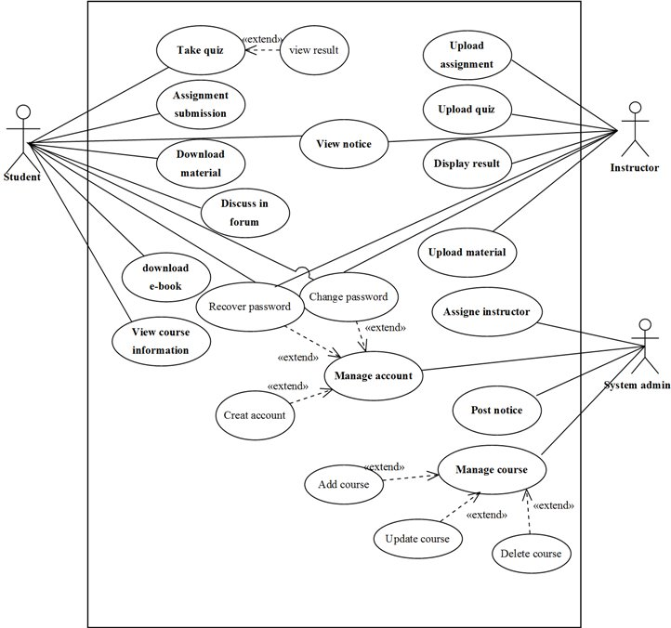

Figure 1: Use case diagram for e-learning management system

All use-cases above<<include>>login and<<extends>>logout but it is complicated to draw in the above use-case diagram.

### Description of use case diagram

|  |  |
| --- | --- |
| Use case id | UC#1 |
| Use case name | Login |
| Participating actor | All system user |
| description | Any user who wants to access the system’s functionality must be Authenticated and Authorized and login to the system. |
| Entry condition | The user must be already register (the user must have user name, password and account type) |
| Flow of event | 1. The user open the system  2. The system display the login page  3. The user enter his/her identification (user type user name and password)  4. The user click on login button  5. The system takes the user to his/her page. |
| Alternative Flow of event | Step 5.1, If the identification is not correct , the system display incorrect user type, user name and password try again message and the system display the login page. The system give chance to try again. |
| Exit condition | The system user logged in to the system |

Table : Login use case description

|  |  |
| --- | --- |
| Use case id | UC#2 |
| Use case name | Create user account |
| Participating actor | System admin |
| description | This use case helps the user when it is necessary to create new user account. |
| Entry condition | user login to the system |
| Flow of event | 1. User selects account from menu bar.  2. The system display user account form.  3. User fills all information and click create button.  4. The system create new user account  5. The system save the new account  6. The system display an acknowledgement successfully create the account |
| Alternative Flow of event | Step 3.1. If user enters wrong the system display message in order to correct wrong information.  Step 4.1. If users enters duplicate account the system display “information already exist” message. |
| Exit condition | A new user account is created |

Table : Create user account use case description

|  |  |
| --- | --- |
| Use case id | UC#3 |
| Use case name | Update user account |
| Participating actor | System admin |
| description | This use case helps the users when he/she wants to update his/her account. |
| Entry condition | User login to the system |
| Flow of event | 1. User selects account from menu bar.  2. The system display user account form.  3. User search account that he/she want to update.  4. The system display information of that account.  5. User makes necessary modification and click Update button.  6. The system asks for confirmation.  7. User click ok button.  8. The system saves the change to that account.  9. The system displays an acknowledgement successfully updating the account. |
| Alternative Flow of event | Step 3.If the user account does not exist the system display “account not found” information. |
| Exit condition | Save the change to the account |

Table : Update user account use case description

|  |  |
| --- | --- |
| Use case id | UC#4 |
| Use case name | Change Password |
| Participating actor | All system user |
| description | This use case helps the user when it is necessary to change login password. |
| Entry condition | user login to the system |
| Flow of event | 1. User selects change password link.  2. The system display password change form.  3. User fills all information and click change button.  4. The system change the password and save the new password  5. The system display an acknowledgement of password change successfully |
| Alternative Flow of event | Step 3. If user enters wrong the system display message in order to correct wrong information.  Step 4. If users input does not exist in the database the system display the password does not exist message |
| Exit condition | Save the changed password |

Table : Change Password use case description

|  |  |
| --- | --- |
| Use case id | UC#5 |
| Use case name | Delete user account |
| Participating actor | System admin |
| description | This use case helps the user to delete user account if it is no more necessary. |
| Entry condition | The user login to the system, the account exists. |
| Flow of event | 1.Users select account from menu bar  2. The system display user account form.  3. Users search account who wants to delete.  4. The system display information of that account.  5. User click delete button.  6. The system deletes the account.  7. The system display an acknowledgement successfully deletes the account. |
| Alternative Flow of event | Step 3.If the user account does not exist the system display “account not found” information. |
| Exit condition | the account is deleted |

Table : Delete user account use case description

|  |  |
| --- | --- |
| Use case id | UC#6 |
| Use case name | Recover forgotten password |
| Participating actor | All system users recover forgotten password |
| Description | The system users may forget their password so this use case help to the system user to recover the forget password . |
| Entry condition | The user must be previously register |
| Flow of event | 1. The user click on forgotten password button  2. The system display forget password recover form  3. The user will enter all required information and click on display button.  4. The system retrieves the password and will display acknowledgment successfully retrieve the password. |
| Alternative Flow of event | Step 4.if the user failure required information the system display the message to fill all required information |
| Exit condition | The user knows their password |

Table : Recover forgotten password use case description

|  |  |
| --- | --- |
| Use case id | UC#7 |
| Use case name | upload quiz |
| Participating actor | Instructor |
| description | This use case helps for instructors to upload the generated questions with their time duration, and additional information about the quiz. |
| Entry condition | Instructor login to the system |
| Flow of event | 1. instructor select on upload quiz menu  2. The system display uploaded form.  3. Instructor searches the prepared exam from the database and click search button.  4. Instructor fills required information and click upload button.  5. The system displays an acknowledgement the information successfully uploaded. |
| Alternative Flow of event | Step 3.1 if the searched quiz does not found in the database the system display the message “the exam is not found”.  Step 4.1. If instructor enters wrong information the system display message in order to correct wrong information. |
| Exit condition | Quizzes are uploaded to the central database. |

Table : Upload quiz use case description

|  |  |
| --- | --- |
| Use case id | UC#8 |
| Use case name | upload assignment |
| Participating actor | Instructor |
| description | This use case helps for instructors to upload the assignment for taking an assessment to student .uploaded information contain the deadline of the assignment ,type of assignment that are work with group or individual and so on. |
| Entry condition | Instructor login to the system |
| Flow of event | 1. Instructor select on upload assignment Menu.  2. The system display form for the use of upload assignment.  3. Instructor fills required information and click upload button.  4. The system displays an acknowledgement the information successfully uploaded. |
| Alternative Flow of event | Step 3.1. If instructor enters wrong information the system display message in order to correct wrong information. |
| Exit condition | Assignments are uploaded to the central database. |

Table : Upload assignment use case description

|  |  |
| --- | --- |
| Use case id | UC#9 |
| Use case name | upload course Material |
| Participating actor | Instructor |
| description | This use case helps for instructors to upload course materials like handout, reference books, video tutorials and syllabus. |
| Entry condition | Instructor login to the system |
| Flow of event | 1. instructor select on upload course material Menu  2. The system display course material upload form.  3. Instructor fills required information and click upload button.  4. The system displays an acknowledgement the information successfully uploaded. |
| Alternative Flow of event | Step 3.1. If instructor enters wrong information the system display message in order to correct wrong information. |
| Exit condition | Course materials are uploaded to the database. |

Table : Upload course material use case description

|  |  |
| --- | --- |
| Use case id | UC#10 |
| Use case name | Assignment submission |
| Participating actor | Student |
| description | This use case helps for student to submit a given assignment to instructors. Student post files for submission to the teacher. |
| Entry condition | Student login to the system |
| Flow of event | 1. Student Selects submit option.  2. System returns options to submit files.  3. Student selects upload files.  4. System returns form to select files, and visibility of those files to the teacher.  5. Student selects file(s) to upload, and visibility and other information about assignment and click submit button.  6The system displays an acknowledgement the information successfully uploaded. |
| Alternative Flow of event | Step 5.1. If student enters wrong information the system display message in order to correct wrong information. |
| Exit condition | The assignment is submitted to instructor. |

Table : Assignment submission use case description

|  |  |
| --- | --- |
| Use case id | UC#11 |
| Use case name | Take quiz |
| Participating actor | Student |
| description | This use case helps for student to solve the given question and submit it to evaluate him/her self |
| Entry condition | Student login to the system |
| Flow of event | 1. Student Selects take quiz option. 2. System returns the form that contain the question and submit button, 3. Student solves the given questions based on the given time and click submit button. 4. The system displays the mark that the student gets. 5. Student click in the preview button to view the correct answer, 6. The system displays the previous questions and its correct answer. |
| Alternative Flow of event | Step 3.1. If student enters wrong information the system display message in order to correct wrong information.  Step 3.2.if the time is end before the student complete the given questions, the system automatically submit the quiz. |
| Exit condition | The quiz is submitted to a database and the result of a given quiz is displayed automatically. |

Table : Take quiz use case description

|  |  |
| --- | --- |
| Use case id | UC#12 |
| Use case name | Download learning material |
| Participating actor | Student |
| description | This use case helps for student to download the course materials that are uploaded by instructors. |
| Entry condition | Student login to the system, the document must be in the form of softcopy. |
| Flow of event | 1. Student Selects download option. 2. System returns the form that contain the document that are uploaded by instructor and download button, 3. Students select the materials and click the download button. 4. The system displays an acknowledgement the information successfully downloaded. |
| Alternative Flow of event | Step 3.1 if item not selected, the System display message download information not done. |
| Exit condition | The documents are downloaded. |

Table : Download learning materials use case description

|  |  |
| --- | --- |
| Use case id | UC#13 |
| Use case name | discuss in forum |
| Participating actor | Student and instructor |
| description | This use case helps for student to forward their idea based on raised questions. Student and instructors participates in this page. |
| Entry condition | Users logs to the system |
| Flow of event | 1. Users Selects forum option. 2. System returns the form that contain the information or question that are concluded in that page, 3. Users replay their idea or answer of question that are raised by other student or instructor. 4. The system displays the reply return to students and display acknowledgement the information successfully replay. |
| Alternative Flow of event | N/G. |
| Exit condition | The ideas are recorded in the discussion forum. |

Table : Discuss in forum use case description

|  |  |
| --- | --- |
| Use case id | UC#14 |
| Use case name | Display result |
| Participating actor | Instructor |
| description | This use case helps for instructors to display the result of student in each course and the grade contains the continuous assessment result. |
| Entry condition | Instructor logs to the system |
| Flow of event | 1. Instructor select grade menu. 2. System returns the form that contains the information for generating grade. 3. Instructor fills all necessary information and click display button. 4. System displays an acknowledgement the information successfully. |
| Alternative Flow of event | Step 3.1. If student enters wrong information the system display message in order to correct wrong information |
| Exit condition | The grade are stored in the database and displayed when the student want. |

Table : Display result use case description

|  |  |
| --- | --- |
| Use case id | UC#15 |
| Use case name | View course information |
| Participating actor | Student |
| description | This use case helps for student to get information about course that means who deliver this course ,credit hour ,any reference that help, assessment mechanism of the course |
| Entry condition | Student login to the system |
| Flow of event | 1. Student select course info menu. 2. System displays all information of course. 3. Student view information’s that he/she want |
| Alternative Flow of event | N/G |
| Exit condition | Students see information that he want. |

Table : View course information use case description

|  |  |
| --- | --- |
| Use case id | UC#16 |
| Use case name | Register course |
| Participating actor | System admin |
| description | This use case helps for the admin to register the available courses that are delivered to student and it contain quiz, assignment, and learning material in to the system. |
| Entry condition | System admin must login to the system |
| Flow of event | 1. Admin select course register link. 2. System returns the form that contains the information for registering course. 3. Admin fill all required information and click register button. 4. System display successful registered acknowledgment. |
| Alternative flow of event | * 1. If student enters wrong information the system display message in order to correct wrong information. |

Table : Register course use case description

|  |  |
| --- | --- |
| Use case id | UC#17 |
| Use case name | Download e-book |
| Participating actor | Student |
| description | This use case helps for student to download books that are not uploaded by the instructor. The system provide link that connect to free e-book site and student simply search the book that they want and download. |
| Entry condition | Student login to the system, the document must be in the form of softcopy. |
| Flow of event | 1. Student Selects go to e-book link. 2. System returns the e-book website that is linked to proposed system. 3. Students sign up to the e-book site. And search the book that he/she want and click download link to download the book. 4. The system displays successfully download information. |
| Alternative Flow of event | Step 3.1 if student fill wrong information to sign up into e-book site, the system display fill the correct information.  Step 3.2 if the searched book is not found, the system displays “not found” information. |
| Exit condition | The documents are downloaded. |

Table : download e-book use case description

|  |  |
| --- | --- |
| Use case id | UC#18 |
| Use case name | Assign instructor |
| Participating actor | System admin |
| description | The system admin assign instructor to each course. |
| Entry condition | System admin login to the system |
| Flow of event | 1. System admin select course assign menu. 2. System displays form that used to assign instructor to each course. 3. System admin fills required information and click assign button. 4. The system displays an acknowledgement the instructor successfully assigned. |
| Alternative Flow of event | Step 3.1. If system admin enters wrong information the system display error message. |
| Exit condition | System admin assign instructor to each course. |

Table : Assign instructor use case description

## Activity Diagram

Activity diagram is another important diagram in UML to describe dynamic aspects of the system. Activity diagram is basically a flow chart to represent the flow from one activity to another activity. The activity can be described as an operation of the system [4].

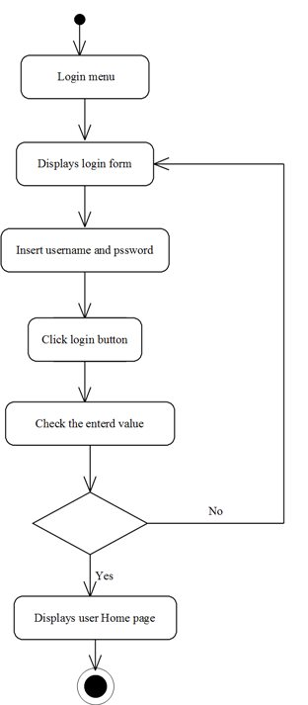

Figure : Activity diagram for login

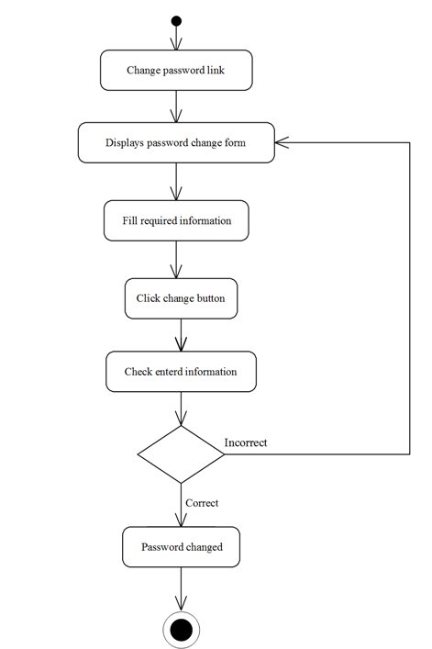

Figure : Activity diagram for change password

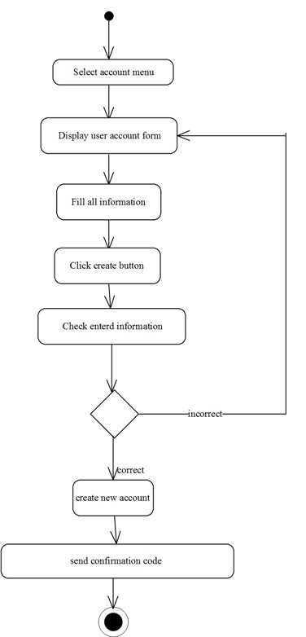

Figure : Activity diagram for create account

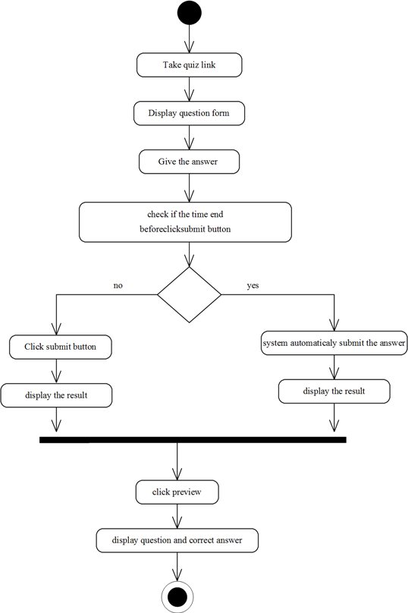

Figure : Activity diagram for take quiz

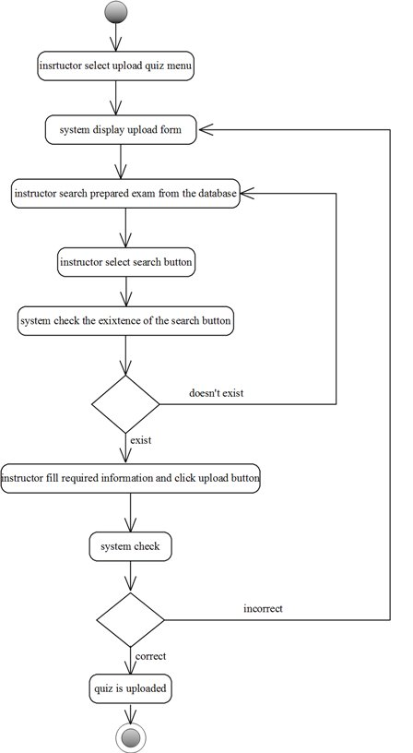

Figure : activity diagram for upload quiz

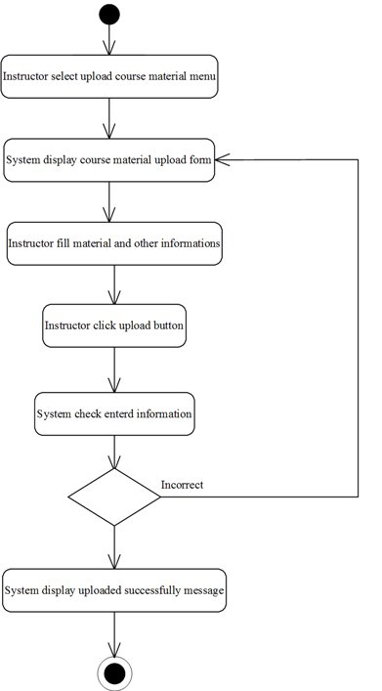

Figure : Activity diagram for upload learning material

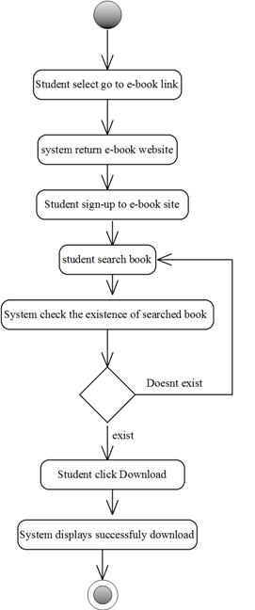

Figure : Activity diagram for download e-book

## Object model

### Data dictionary

|  |  |  |  |  |  |
| --- | --- | --- | --- | --- | --- |
| **Field name** | **Data type** | **Caption** | **null** | **Key** | **Field size** |
| Stu_Id | String | Student Identification number | No | Pk /key | 50 |
| F_ name | Text | first name | No |  | 50 |
| L_ name | Text | Last name | No |  | 50 |
| Age | Integer | Age | No |  | 50 |
| Password | String | Password | No |  | 50 |
| E- mail | String | Email address | No |  | 50 |
| Department | Text | Department | No |  | 50 |
| Year | Text | Year | No |  | 50 |

Table : Data dictionary for student

|  |  |  |  |  |  |
| --- | --- | --- | --- | --- | --- |
| **Field name** | **Data type** | **Caption** | **null** | **Key** | **Field size** |
| Ins _id | String | Instructor identification number | No | Pk /key | 50 |
| F_ name | Text | first name | No |  | 50 |
| L_ name | Text | Last name | No |  | 50 |
| Password | String | Password | No |  | 50 |
| E- mail | String | Email address | No |  | 50 |
| Department | Text | Department | No |  | 50 |

Table : Data dictionary for instructor

|  |  |  |  |  |  |
| --- | --- | --- | --- | --- | --- |
| **Field name** | **Data type** | **Caption** | **null** | **Key** | **Field size** |
| id no | String | identification number | No | Pk /key | 50 |
| F_ name | Text | first name | No |  | 50 |
| L_ name | Text | Last name | No |  | 50 |
| Password | String | Password | No |  | 50 |
| E- mail | String | Email address | No |  | 50 |

Table : Data dictionary for system admin

### Class diagram

The class model shows static class objects in a system and the relationships between them. Two particularly important relationships are generalization and aggregation. Each class object on the diagram often shows the class name, its attributes and operations.

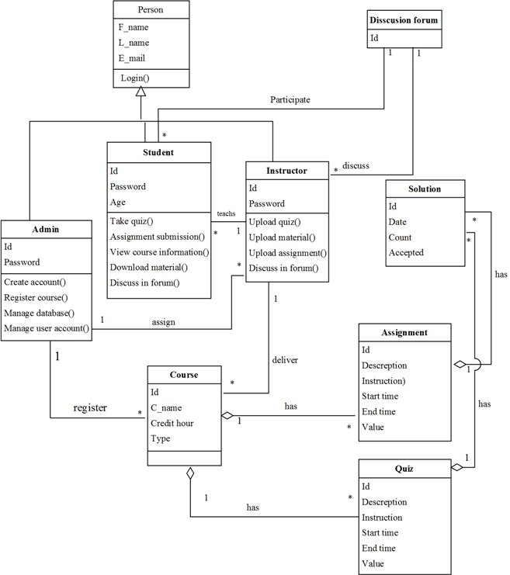

Figure : Class diagram for e-learning management system

## Dynamic model

### Sequence diagram

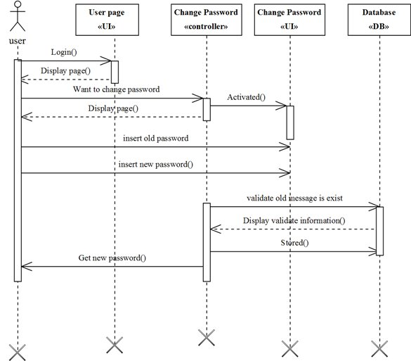

Figure : Sequence diagram for change password

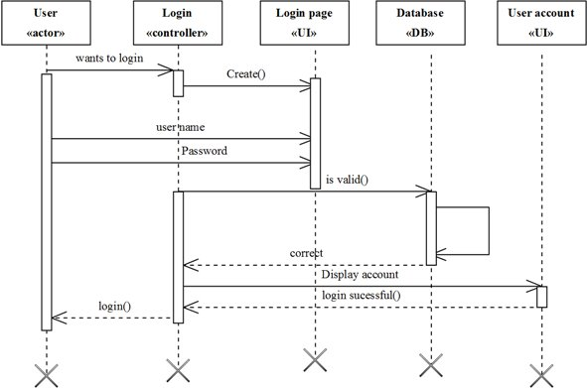

Figure : Sequence diagram for login

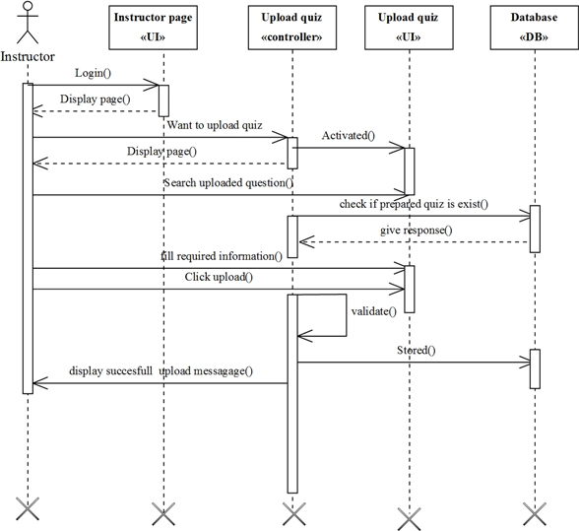

Figure : Sequence diagram for upload quiz

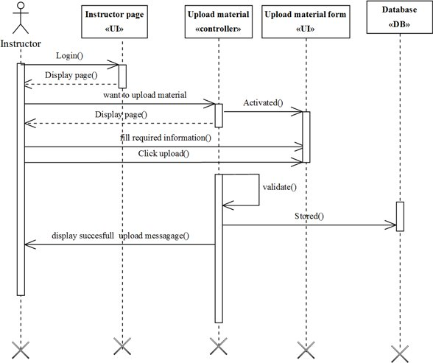

Figure : Sequence diagram for upload materials

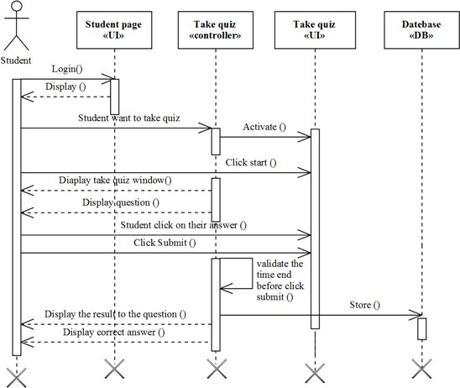

Figure : Sequence diagram for taking quiz

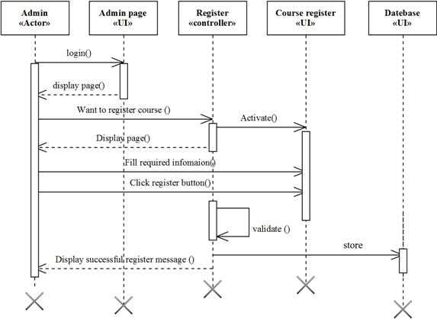

Figure : Sequence diagram for register course

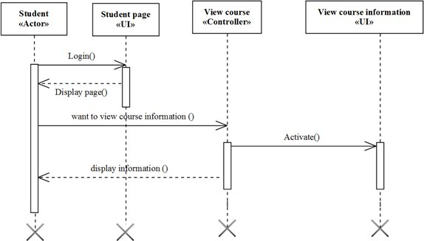

Figure : Sequence diagram for view course information

### State chart diagram

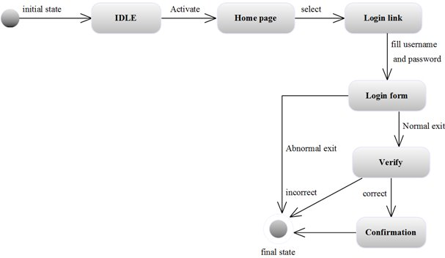

Figure : State diagram for login

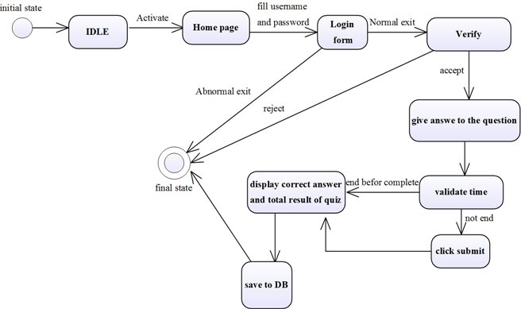

Figure : State diagram for take quiz

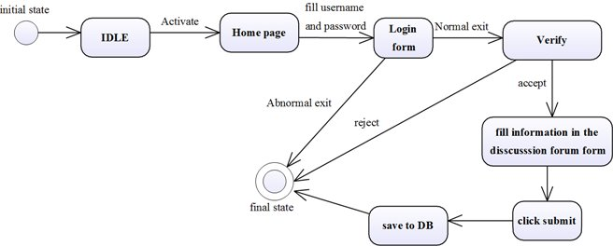

Figure : State diagram for discussion forum

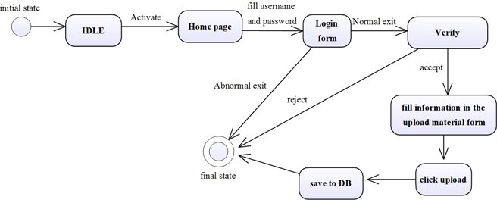

Figure : State diagram for upload material

## User interface



Figure : Home page for proposed system



Figure : Login page for proposed system

# CHAPTER THREE

## Introduction

The purpose of designing is to show the direction how the web page is built and to obtain clear and enough information needed to drive the actual implementation of web page. It is based on understanding of the model. The web page built on system design also focuses on decomposing the system in to manageable parts

This design part of the project includes all object oriented diagrams including subsystem decomposition, proposed system architecture, component diagram and finally deployment diagram. This all diagram represent the requirement and on what way to solve the requirement of the proposed application in detail.

### Design Goals

**Design goals describe the qualities of the system that the developers should consider. These goals can be drawn from the non-functional requirements already discussed. The design goals can be generally grouped into five categories. These are: Performance criteria,** Error handling condition **criteria, Cost criteria, Maintenance criteria, and End user criteria.**

* **Performance: e-learning management system should respond fast with high throughput, i.e. it should perform searching information, uploading and downloading materials, registration processing and taking quiz in a time less than a minute.**
* **Error handling condition: e-learning management system should be robust (forceful) i.e. it should be able to carry on invalid user inputs, fault tolerant, reliable and available. The system shouldn’t allow non-authorized users to access students’ personal data or modify.**
* **Cost: e-learning management system should be developed, deployed, administered and maintained with minimum cost possible.**
* **Maintenance**: **The system should be easily extensible to modify the uploading materials, add new functionality, portable to different platforms. The code for the system should be easily readable, understandable and should be easily mapped to specific requirements.**
* **End User Criteria**: **The system should have simple and understandable graphical user interface such as forms and buttons which have descriptive names. It should give reliable response for each user request at least before the session expires.**
* **Usability: Usability is the extent to which a product can be used by specified users to achieve specified goals with effectiveness, efficiency and satisfaction in a specified context of use. From the end users’ perspective the system should be designed in such a way that it is easy to learn and use, efficient and having few errors if any.**

## Current software architecture

The existing system of UOG learning management system is manual system and hence there is no existing software architecture that will be considered. As a result, we only describe the software architecture of the newly proposed system.

## Proposed software architecture

### Overview

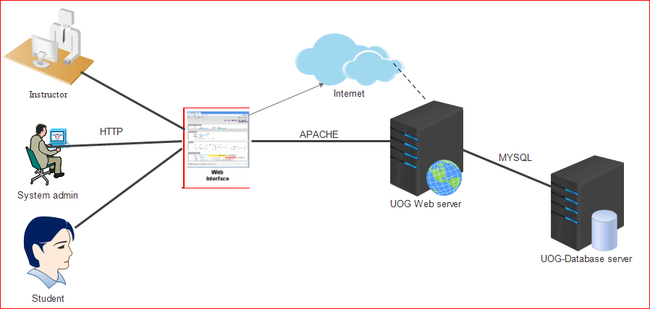

Figure : Software architecture for proposed system

Software architecture refers to the subsystem decomposition in terms of subsystem responsibilities, dependencies among subsystems, subsystem mapping to hardware, and Major policy decisions such as control flow, access control, and data storage.

The proposed system will have three tier client-server software architectures .A client i.e. the computer, which requests the resource, equipped with user interface (usually web browser for presentation purposes. the application server (also middleware), whose task it is to provide the requested resources but by calling on another server. the data server which provides the application server with the data it required.

### Subsystem decomposition

Subsystem decomposition describes the decomposition into subsystems and the responsibilities of each. During decomposition of the system we decompose our system in to individual unit that can be perform by one team member and one subsystem modification do not affect the other subsystem and each subsystem class are related with each other. Our system has the following sub system.

* **Quiz Management** **subsystems**, which facilitate the design and authoring of quizzes and tests, which are published on the WWW and taken on-line. They provide tools for on-line delivery, automatic grading, results manipulation and report generation.
* **Communication management subsystem**
* **Course material management subsystem**
* **User administration subsystem**

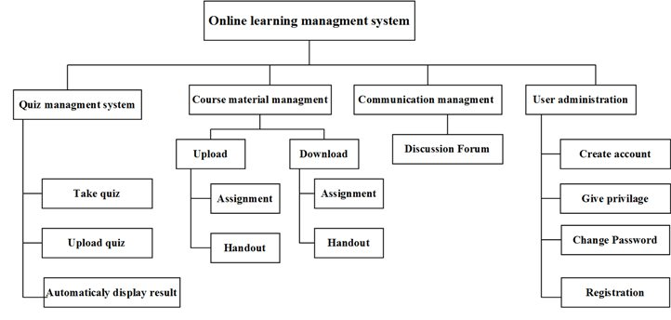

Figure : E- Learning management system decomposition

## Component diagram

In this diagram components of the system will be energetic showing that there is relation among components, management of the system, database and operations performed on databases such security issue. This in some area shows which component or objects will be accessed by whom and what type of security infrastructures it is using. The diagram is simulated below.



Figure : Component diagram for proposed system

## Hardware/software mapping

In this system deployment mode is showing the hardware of the system, the software that is installed in the hardware and also the middleware that is used to connect the dissimilar machines to one and other. It also shows how the software and the hardware components work together.

The architecture of our system is a 3 tier Client/Server Architecture where a client can use Internet browsers to access the e-learning management system provided by the system within compound of university using the Internet.

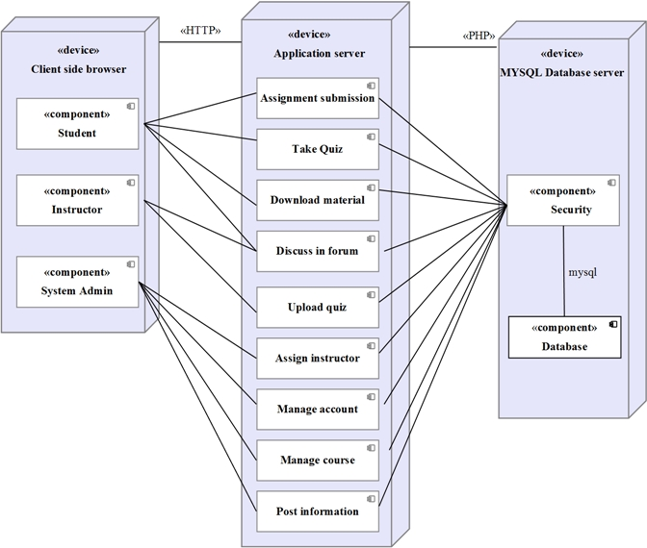

Figure : Deployment diagram for proposed system

## Persistent data management

The persistent data of e-learning management system are the data that are accessed by the users permanently in the database .out team member represent this persistent data in the form of object diagram.



Figure : Persistent data diagram for e-learning management system

## Access control and security

The actors of the proposed system have their own privilege to access authorize information we describe it by using access control matrix.

|  |  |  |  |  |
| --- | --- | --- | --- | --- |
| Actors | Quiz Management | Course material management | Communication management system | User system administration |
| System admin | Manage all activity () | Assign instructor()  Post information () |  | Create user account ()  Update user account()  Delete user account()  Change password()  Recover forget password |
| Instructor | Upload quiz () | Upload course material ()  Upload Assignment ()  Update course material ()  Update Assignment ()  Delete course material ()  Delete Assignment () | Discuss in discussion forum () | Change password ()  Recover forget password() |
| Student | Submit quiz ()  View result () | Download course material()  Download Assignment()  Download e-book | Discuss in the discussion forum () | Change password ()  Recover forget password() |

Table : Table of access control and security

## Detailed Class Diagram

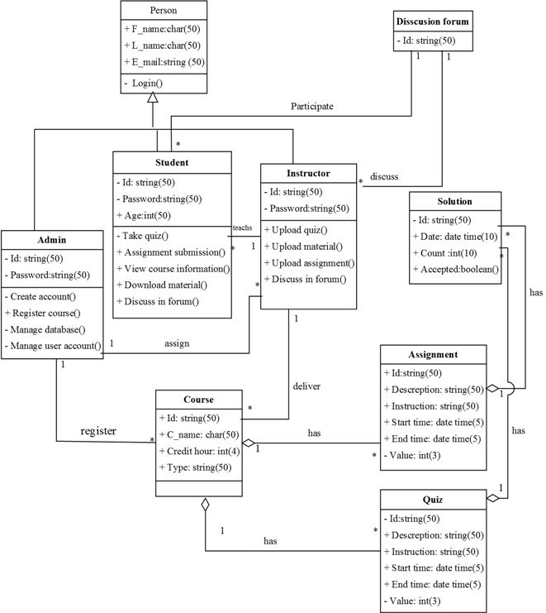

Figure : Detailed class diagram for e-learning management system

## Subsystem services

* **Quiz Management** **subsystems**, which facilitate the design and authoring of quizzes and tests, which are published on the WWW and taken on-line. They provide tools for test creation and their on-line delivery, automatic grading, results manipulation and report generation.
* **Communication management subsystem** which facilitatethe communication among instructors and students by designing discussion forum.
* **Course material management subsystem** which facilitatealmost all activities of learning management system that contains upload and download learning materials and assignments.
* **User administration subsystem** which facilitate and manage the user account including create account, change password, recovery password.

## Packages diagram

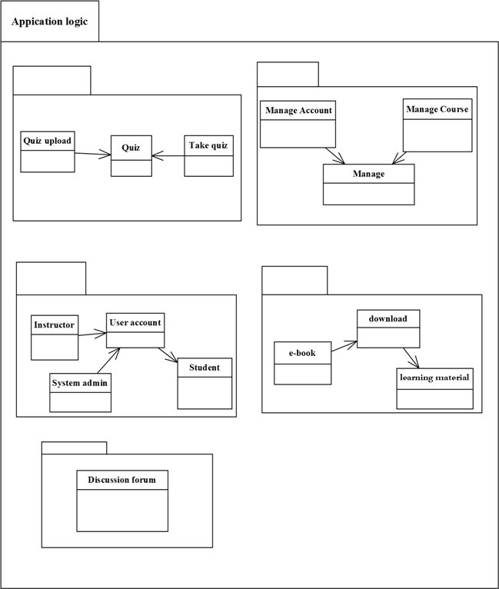

Figure : Package diagram for proposed system

# Chapter four

## Introduction

Implementation refers to the Coding of the all documents gathered starting from requirement analysis to Design phase. So now the team is in a position of converting all documents gathered and designed into the code so that the system will be implemented for the user to be used for the purpose it developed. To implement it the user must have a server on which the system will be hosted because this system can run on intranet site with connection available or on internet connection.

## Sample code and their screen image

### Home page



Figure : Home page of e-learning management system

### Login page



Figure : Login page

<!DOCTYPE html>

<?php

//include("lng.php"); ?>

<html>

<head>

<title>e-learning</title>

<meta charset="utf-8">

<meta name="viewport" content="width=device-width, initial-scale=1.0, maximum-scale=1.0, user-scalable=no">

<!--<link href="layout/styles/layout.css" rel="stylesheet" type="text/css" media="all">-->

<link rel="stylesheet" href="assets/plugins/bootstrap/css/bootstrap.css" />

<link rel="stylesheet" href="assets/css/login.css" />

<link href="layout/styles/layout.css" rel="stylesheet" type="text/css" media="all">

<link rel="stylesheet" href="assets/plugins/magic/magic.css" />

</head>

<?php

include('admin/connect.php');

session_start();

unset($_SESSION['id']);

?>

<body id="top">

<div class="wrapper row0">

<div id="topbar" class="clear">

<nav>

<ul>

<li><a href="Alogin.php">Admin Login</a></li>

<li><a href="Ilogin.php">Instructor Login</a></li>

<li><a href="login.php">Student Login</a></li>

<!--<li><a href="?lan=am">Amharic</a></li>

<li><a href="?lan=en">English</a></li>-->

</ul>

</nav>

</div>

</div>

</div>

</div>

</div>

<div class="wrapper row1">

<header id="header" class="clear">

<div id="logo" class="fl_left">

<h1><a href="index.html">UOG E-LEARNING MANAGMENT SYSTEM</a></h1>

</div>

</header>

</div>

<div class="wrapper row2">

<div class="rounded">

<nav id="mainav" class="clear">

<ul class="clear">

<li class="active"><a href="index.php">Home</a></li>

<li><a class="drop" href="aboutus.php">About us</a>

</li>

<li><a class="drop" href="contactus.php">contact us</a>

</li>

<li><a href="#">e-learning tips</a></li>

</ul>

</nav>

</div>

</div>

<div class="wrapper">

<div id="slider">

<div id="slide-wrapper" class="rounded clear">

<figure id="slide-5"><img src="images/demo/banner_r1_c1.jpg" alt="">

</figure>

</div>

</div>

</div>

<div class="wrapper row3">

<div class="rounded">

<main class="container clear">

<!-- main body -->

<div class="group btmspace-30">

<!-- Left Column -->

<div class="tab-content">

<div >

<form action="" method="post" class="form-signin">

<p class="text-muted text-center btn-block btn btn-primary btn-rect">

Enter your username and password

</p>

<input type="text" placeholder="Username" name="Username" class="form-control" />

<input type="password" placeholder="Password" name="Password" class="form-control" />

<button class="btn text-muted text-center btn-danger" name="login" type="submit">Sign in</button>

<?php

if (isset($_POST['login'])) {

function clean($str) {

$str = @trim($str);

if (get_magic_quotes_gpc()) {

$str = stripslashes($str);

}

return mysql_real_escape_string($str);

}

$username = clean($_POST['Username']);

$password = clean(base64_encode($_POST['Password']));

$query = mysql_query("select * from student where username='$username' and password='$password'") or die(mysql_error());

$count = mysql_num_rows($query);

$row = mysql_fetch_array($query);

if ($count > 0) {

session_start();

session_regenerate_id();

$_SESSION['id'] = $row['student_id'];

header('location:student/home.php');

session_write_close();

exit();

} else {

session_write_close();

?>

<div class="pull-right">

<button type="button" class="close" data-dismiss="alert">&times;</button>

<div class="alert alert-danger"><i class="icon-remove-sign"></i>&nbsp;Incorect password and email</div>

</div>

<?php

//echo "Incorect password and email";

exit();

}

}

?>

</form>

</div>

<div class="text-center">

<ul class="list-inline">

<li><a href="login.php" >Login</a></li>

<li><a href="forgot.php">Forgot Password</a></li>

</ul>

</div>

<!-- / Middle Column -->

</div>

</div>

</div>

<!-- / main body -->

<div class="clear"></div>

</main>

</div>

</div>

<div class="wrapper row4">

<div class="rounded">

<footer id="footer" class="clear">

<div class="one_third first">

<figure class="center"><img class="btmspace-15" src="images/demo/worldmap.png" alt="">

<figcaption><a href="#">Find Us With Google Maps &raquo;</a></figcaption>

</figure>

</div>

<div class="one_third">

<address>

University Of Gondar<br>

Department Of Information systems

Gondar<br>

Postcode<br>

<br>

<i class="fa fa-phone pright-10"></i> 0581141237<br>

<i class="fa fa-envelope-o pright-10"></i> <a href="#">196</a>

</address>

</div>

<div class="one_third">

<p class="nospace btmspace-10">Stay Up to Date With What's Happening</p>

<ul class="faico clear">

<li><a class="faicon-twitter" href="#"><i class="fa fa-twitter"></i></a></li>

<li><a class="faicon-linkedin" href="#"><i class="fa fa-linkedin"></i></a></li>

<li><a class="faicon-facebook" href="#"><i class="fa fa-facebook"></i></a></li>

<li><a class="faicon-flickr" href="#"><i class="fa fa-flickr"></i></a></li>

<li><a class="faicon-rss" href="#"><i class="fa fa-rss"></i></a></li>

</ul>

<form class="clear" method="post" action="#">

<fieldset>

<legend>Subscribe To Our Newsletter:</legend>

<input type="text" value="" placeholder="Enter Email Here&hellip;">

<button class="fa fa-sign-in" type="submit" title="Sign Up"><em>Sign Up</em></button>

</fieldset>

</form>

</div>

</footer>

</div>

</div>

### Forgot password



Figure : Forgot password for users

<!DOCTYPE html>

<?php

//include("lng.php"); ?>

<html>

<head>

<title>e-learning</title>

<meta charset="utf-8">

<meta name="viewport" content="width=device-width, initial-scale=1.0, maximum-scale=1.0, user-scalable=no">

<!--<link href="layout/styles/layout.css" rel="stylesheet" type="text/css" media="all">-->

<link rel="stylesheet" href="assets/plugins/bootstrap/css/bootstrap.css" />

<link rel="stylesheet" href="assets/css/login.css" />

<link href="layout/styles/layout.css" rel="stylesheet" type="text/css" media="all">

<link rel="stylesheet" href="assets/plugins/magic/magic.css" />

</head>

<?php

include('admin/connect.php');

session_start();

unset($_SESSION['id']);

?>

<body id="top">

<div class="wrapper row0">

<div id="topbar" class="clear">

<nav>

<ul>

<li><a href="Alogin.php">Admin Login</a></li>

<li><a href="Ilogin.php">Instructor Login</a></li>

<li><a href="login.php">Student Login</a></li>

<!--<li><a href="?lan=am">Amharic</a></li>

<li><a href="?lan=en">English</a></li>-->

</ul>

</nav>

</div>

</div>

</div>

</div>

</div>

<div class="wrapper row1">

<header id="header" class="clear">

<div id="logo" class="fl_left">

<h1><a href="index.html">UOG E-LEARNING MANAGMENT SYSTEM</a></h1>

</div>

</header>

</div>

<div class="wrapper row2">

<div class="rounded">

<nav id="mainav" class="clear">

<ul class="clear">

<li class="active"><a href="index.php">Home</a></li>

<li><a class="drop" href="aboutus.php">About us</a>

</li>

<li><a class="drop" href="contactus.php">contact us</a>

</li>

<li><a href="#">e-learning tips</a></li>

</ul>

</nav>

</div>

</div>

<div class="wrapper">

<div id="slider">

<div id="slide-wrapper" class="rounded clear">

<figure id="slide-5"><img src="images/demo/banner_r1_c1.jpg" alt="">

</figure>

</div>

</div>

</div>

<div class="wrapper row3">

<div class="rounded">

<main class="container clear">

<!-- main body -->

<div class="group btmspace-30">

<!-- Left Column -->

<div class="tab-content">

<div >

<form action="" method="post" class="form-signin">

<p class="text-muted text-center btn-block btn btn-primary btn-rect">

Enter your username and password

</p>

<input type="text" placeholder="Username" name="Username" class="form-control" />

<input type="password" placeholder="Password" name="Password" class="form-control" />

<button class="btn text-muted text-center btn-danger" name="login" type="submit">Sign in</button>

<?php

if (isset($_POST['login'])) {

function clean($str) {

$str = @trim($str);

if (get_magic_quotes_gpc()) {

$str = stripslashes($str);

}

return mysql_real_escape_string($str);

}

$username = clean($_POST['Username']);

$password = clean(base64_encode($_POST['Password']));

$query = mysql_query("select * from student where username='$username' and password='$password'") or die(mysql_error());

$count = mysql_num_rows($query);

$row = mysql_fetch_array($query);

if ($count > 0) {

session_start();

session_regenerate_id();

$_SESSION['id'] = $row['student_id'];

header('location:student/home.php');

session_write_close();

exit();

} else {

session_write_close();

?>

<div class="pull-right">

<button type="button" class="close" data-dismiss="alert">&times;</button>

<div class="alert alert-danger"><i class="icon-remove-sign"></i>&nbsp;Incorect password and email</div>

</div>

<?php

//echo "Incorect password and email";

exit();

}

}

?>

</form>

</div>

<div class="text-center">

<ul class="list-inline">

<li><a href="login.php" >Login</a></li>

<li><a href="forgot.php">Forgot Password</a></li>

</ul>

</div>

### Profile

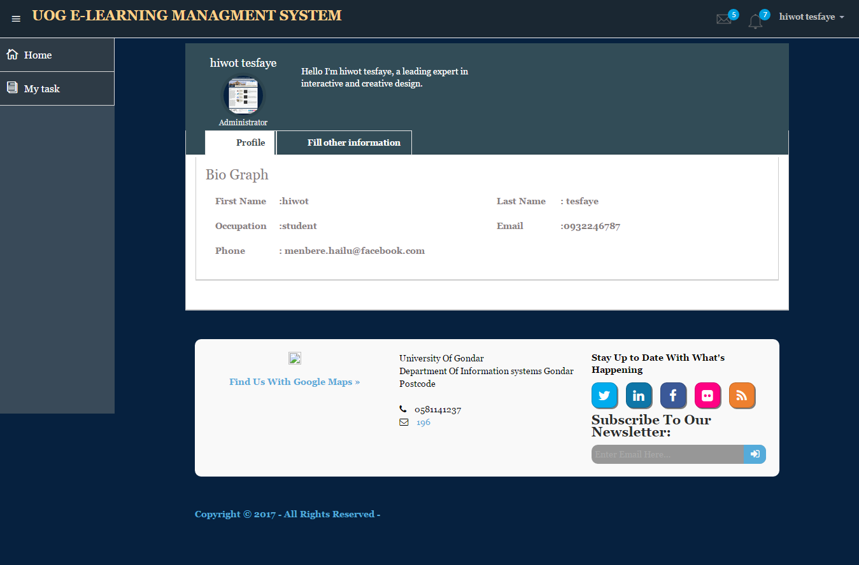

Figure : Profile page for student

<!DOCTYPE html>

<html lang="en">

<head>

<meta charset="utf-8">

<meta name="viewport" content="width=device-width, initial-scale=1.0">

<meta name="description" content="Creative - Bootstrap 3 Responsive Admin Template">

<meta name="author" content="GeeksLabs">

<meta name="keyword" content="Creative, Dashboard, Admin, Template, Theme, Bootstrap, Responsive, Retina, Minimal">

<link rel="shortcut icon" href="img/favicon.png">

<title>Profile</title>

<!-- Bootstrap CSS -->

<link href="../css/bootstrap.min.css" rel="stylesheet">

<!-- bootstrap theme -->

<link href="../css/bootstrap-theme.css" rel="stylesheet">

<!--external css-->

<!-- font icon -->

<link href="../css/elegant-icons-style.css" rel="stylesheet" />

<link href="../css/font-awesome.min.css" rel="stylesheet" />

<!-- Custom styles -->

<link href="../css/style.css" rel="stylesheet">

<link href="../css/style-responsive.css" rel="stylesheet" />

<link href="../layout/styles/layout.css" rel="stylesheet" type="text/css" media="all">

</head>

<?php

include('connect.php');

include('session.php');

?>

<body>

<!-- container section start -->

<section id="container" class="">

<!--header start-->

<header class="header dark-bg">

<div class="toggle-nav">

<div class="icon-reorder tooltips" data-original-title="Toggle Navigation" data-placement="bottom"><i class="icon_menu"></i></div>

</div>

<!--logo start-->

<a href="index.html" class="logo"><strong>UOG E-LEARNING MANAGMENT SYSTEM<strong></a>

<!--logo end-->

<div class="top-nav notification-row">

<!-- notificatoin dropdown start-->

<ul class="nav pull-right top-menu">

<!-- inbox notificatoin start-->

<li id="mail_notificatoin_bar" class="dropdown">

<a data-toggle="dropdown" class="dropdown-toggle" href="#">

<i class="icon-envelope-l"></i>

<span class="badge bg-important">5</span>

</a>

<ul class="dropdown-menu extended inbox">

<div class="notify-arrow notify-arrow-blue"></div>

<li>

<p class="blue">You have 5 new messages</p>

</li>

<li>

<a href="#">

<span class="photo"><img alt="avatar" src="./img/avatar-mini.jpg"></span>

<span class="subject">

<span class="from">Greg Martin</span>

<span class="time">1 min</span>

</span>

<span class="message">

I really like this admin panel.

</span>

</a>

</li>

<li>

<a href="#">

<span class="photo"><img alt="avatar" src="./img/avatar-mini2.jpg"></span>

<span class="subject">

<span class="from">Bob Mckenzie</span>

<span class="time">5 mins</span>

</span>

<span class="message">

Hi, What is next project plan?

</span>

</a>

</li>

<li>

<a href="#">

<span class="photo"><img alt="avatar" src="./img/avatar-mini3.jpg"></span>

<span class="subject">

<span class="from">Phillip Park</span>

<span class="time">2 hrs</span>

</span>

<span class="message">

I am like to buy this Admin Template.

</span>

</a>

</li>

<li>

<a href="#">

<span class="photo"><img alt="avatar" src="./img/avatar-mini4.jpg"></span>

<span class="subject">

<span class="from">Ray Munoz</span>

<span class="time">1 day</span>

</span>

<span class="message">

Icon fonts are great.

</span>

</a>

</li>

<li>

<a href="#">See all messages</a>

</li>

</ul>

</li>

<!-- inbox notificatoin end -->

<!-- alert notification start-->

<li id="alert_notificatoin_bar" class="dropdown">

<a data-toggle="dropdown" class="dropdown-toggle" href="#">

<i class="icon-bell-l"></i>

<span class="badge bg-important">7</span>

</a>

<ul class="dropdown-menu extended notification">

<div class="notify-arrow notify-arrow-blue"></div>

<li>

<p class="blue">You have 4 new notifications</p>

</li>

<li>

<a href="#">

<span class="label label-primary"><i class="icon_profile"></i></span>

Friend Request

<span class="small italic pull-right">5 mins</span>

</a>

</li>

<li>

<a href="#">

<span class="label label-warning"><i class="icon_pin"></i></span>

John location.

<span class="small italic pull-right">50 mins</span>

</a>

</li>

<li>

<a href="#">

<span class="label label-danger"><i class="icon_book_alt"></i></span>

Project 3 Completed.

<span class="small italic pull-right">1 hr</span>

</a>

</li>

<li>

<a href="#">

<span class="label label-success"><i class="icon_like"></i></span>

Mick appreciated your work.

<span class="small italic pull-right"> Today</span>

</a>

</li>

<li>

<a href="#">See all notifications</a>

</li>

</ul>

</li>

<!-- alert notification end-->

<!-- user login dropdown start-->

<li class="dropdown">

<?php

$query = mysql_query("select * from student where student_id='$session_id'") or die(mysql_error());

$row = mysql_fetch_array($query) ;

$user_id = $row['student_id'];

?>

<!-- script -->

<script type="text/javascript">

$(document).ready(function(){

$('#d<?php echo $student_id; ?>').tooltip('show')

$('#d<?php echo $student_id; ?>').tooltip('hide')

});

</script>

<a data-toggle="dropdown" class="dropdown-toggle" href="#">

<span class="username"><?php echo $row['firstname'] . " " . $row['lastname']; ?></span>

<b class="caret"></b>

</a>

<ul class="dropdown-menu extended logout">

<div class="log-arrow-up"></div>

<li class="eborder-top">

<a href="#"><i class="icon_profile"></i> My Profile</a>

</li>

<li>

<a href="#"><i class="icon_mail_alt"></i> My Inbox</a>

</li>

<li>

<a href="logout.php"><i class="icon_key_alt"></i> Log Out</a>

</li>

</ul>

</li>

<!-- user login dropdown end -->

</ul>

<!-- notificatoin dropdown end-->

</div>

</header>

<!--header end-->

<!--sidebar start-->

<aside>

<div id="sidebar" class="nav-collapse ">

<!-- sidebar menu start-->

<ul class="sidebar-menu">

<li class="active">

<a class="" href="home.php">

<i class="icon_house_alt"></i>

<span>Home</span>

</a>

</li>

<li class="active">

<a href="student_class.php" class="">

<i class="icon_documents_alt"></i>

<span>My task</span>

</a>

</li>

</ul>

<!-- sidebar menu end-->

</div>

</aside>

<!--sidebar end-->

<!--main content start-->

<section id="main-content">

<section class="wrapper">

<div class="row">

<div class="col-lg-12">

<ol class="breadcrumb">

<li><i class="fa fa-home"></i><a href="profile.html">Home</a></li>

</ol>

</div>

</div>

<div class="row">

<!-- profile-widget -->

<div class="col-lg-12">

<div class="profile-widget profile-widget-info">

<div class="panel-body">

<div class="col-lg-2 col-sm-2">

<h4><?php echo $row['firstname'] . " " . $row['lastname']; ?></h4>

<div class="follow-ava">

<img src="<?php echo $row['location']; ?>" alt="">

</div>

<h6>Administrator</h6>

</div>

<div class="col-lg-4 col-sm-4 follow-info">

<p>Hello I’m <?php echo $row['firstname'] . " " . $row['lastname']; ?>, a leading expert in interactive and creative design.</p>

</div>

</div>

</div>

</div>

</div>

<!-- page start-->

<div class="row">

<div class="col-lg-12">

<section class="panel">

<header class="panel-heading tab-bg-info">

<ul class="nav nav-tabs">

<li>

<a data-toggle="tab" href="#profile">

<i class="icon-user"></i>

Profile

</a>

</li>

<li class="">

<a href="edit_profile.php">

<i class="icon-envelope"></i>

Fill other information

</a>

</li>

</ul>

</header>

<div class="panel-body">

<div class="tab-content">

<!-- profile -->

<?php

$query = mysql_query("select * from student,teacher_information where teacher_information.student_id=student.student_id and student.student_id='$session_id'") or die(mysql_error());

$row = mysql_fetch_array($query) ;

?>

<div id="profile" class="tab-pane">

<section class="panel">

<div class="panel-body bio-graph-info">

<h1>Bio Graph</h1>

<div class="bio-row">

<p><span>First Name </span>:<?php echo $row['firstname'];?> </p>

</div>

<div class="bio-row">

<p><span>Last Name </span>: <?php echo $row['lastname'];?></p>

</div>

<div class="bio-row">

<p><span>Occupation </span>:<?php echo $row['occupation'];?></p>

</div>

<div class="bio-row">

<p><span>Email </span>:<?php echo $row['email'];?></p>

</div>

<div class="bio-row">

<p><span>Phone </span>: <?php echo $row['mobile'];?></p>

</div>

</div>

</section>

<section>

<div class="row">

</div>

</section>

</div>

</div> </div> </div> </div>

<div class="wrapper row4">

<div class="rounded">

<footer id="footer" class="clear">

<!-- ################################################################################################ -->

<div class="one_third first">

<figure class="center"><img class="btmspace-15" src="images/demo/worldmap.png" alt="">

<figcaption><a href="#">Find Us With Google Maps &raquo;</a></figcaption>

</figure>

</div>

<div class="one_third">

<address>

University Of Gondar<br>

Department Of Information systems

Gondar<br>

Postcode<br>

<br>

<i class="fa fa-phone pright-10"></i> 0581141237<br>

<i class="fa fa-envelope-o pright-10"></i> <a href="#">196</a>

</address>

</div>

<div class="one_third">

<p class="nospace btmspace-10">Stay Up to Date With What's Happening</p>

<ul class="faico clear">

<li><a class="faicon-twitter" href="#"><i class="fa fa-twitter"></i></a></li>

<li><a class="faicon-linkedin" href="#"><i class="fa fa-linkedin"></i></a></li>

<li><a class="faicon-facebook" href="#"><i class="fa fa-facebook"></i></a></li>

<li><a class="faicon-flickr" href="#"><i class="fa fa-flickr"></i></a></li>

<li><a class="faicon-rss" href="#"><i class="fa fa-rss"></i></a></li>

</ul>

<form class="clear" method="post" action="#">

<fieldset>

<legend>Subscribe To Our Newsletter:</legend>

<input type="text" value="" placeholder="Enter Email Here&hellip;">

<button class="fa fa-sign-in" type="submit" title="Sign Up"><em>Sign Up</em></button>

</fieldset>

</form>

</div>

</footer>

</div>

</div>

<div class="wrapper row5">

<div id="copyright" class="clear">

<p class="fl_left">Copyright &copy; 2017 - All Rights Reserved - </p>

</div>

</div>

<!-- container section end -->

<!-- javascripts -->

<script src="js/jquery.js"></script>

<script src="js/bootstrap.min.js"></script>

<!-- nice scroll -->

<script src="js/jquery.scrollTo.min.js"></script>

<script src="js/jquery.nicescroll.js" type="text/javascript"></script>

<!-- jquery knob -->

<script src="assets/jquery-knob/js/jquery.knob.js"></script>

<!--custome script for all page-->

<script src="js/scripts.js"></script>

<!--<script src="layout/scripts/jquery.min.js"></script>

<script src="layout/scripts/jquery.fitvids.min.js"></script>

<script src="layout/scripts/jquery.mobilemenu.js"></script>

<script src="layout/scripts/tabslet/jquery.tabslet.min.js"></script>-->

<script>

//knob

$(".knob").knob();

</script>

</body>

</html>

### Upload quiz



Figure : Upload quiz

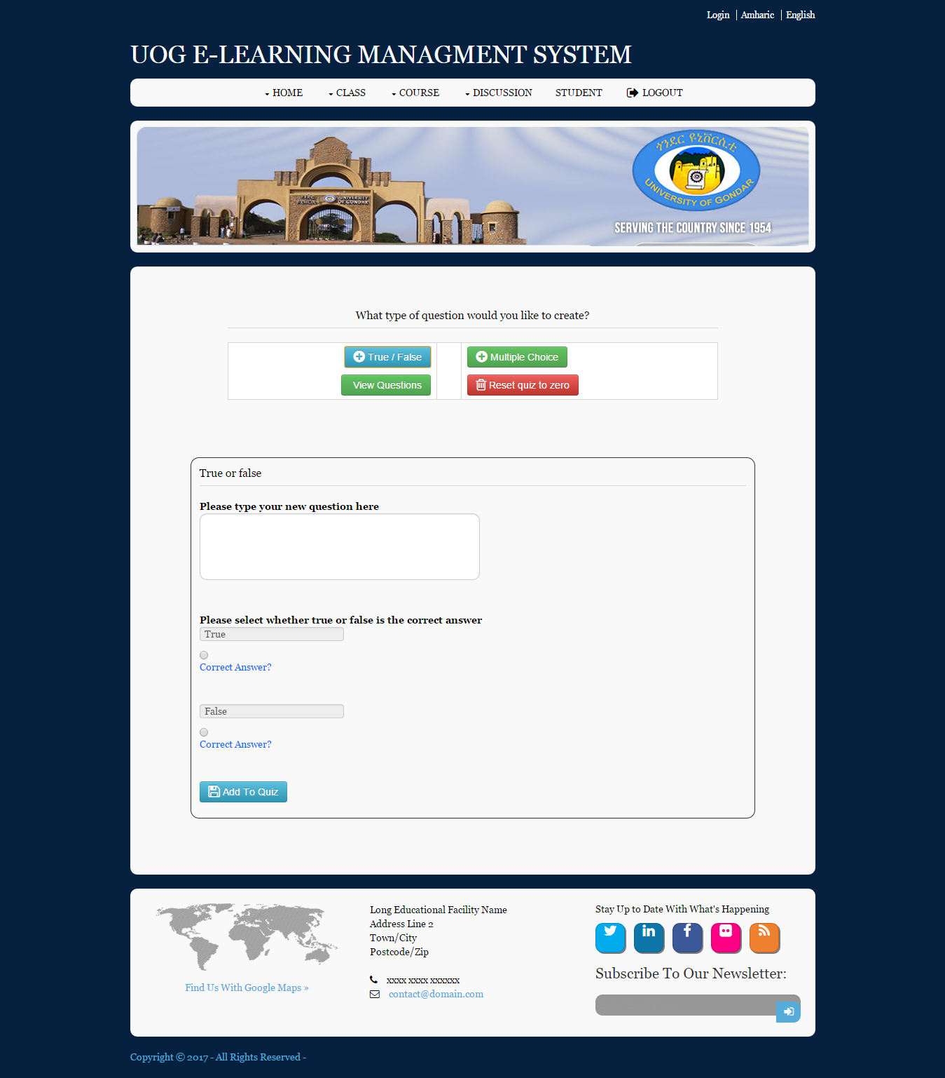

Figure : Add question to quiz.

<?php

//$get_id=$_GET['qid'];

include("../scripts/connect_db.php");

include ('session.php');

$user_query = mysql_query("select * from teacher where teacher_id='$session_id'") or die(mysql_error());

$user_row = mysql_fetch_array($user_query);

//$quiz_id=$section_row['quiz_id'];

?>

<?php

//checking if the required data has been filled

if(isset($_POST['desc'])){

if(!isset($_POST['iscorrect']) || $_POST['iscorrect'] == ""){

echo "Sorry, important data to submit your question is missing. Please press back in your browser and try again and make sure you select a correct answer for the question.";

exit();

}

if(!isset($_POST['type']) || $_POST['type'] == ""){

echo "Sorry, there was an error parsing the form. Please press back in your browser and try again";

exit();

}

//connecting to the database

require_once("../scripts/connect_db.php");

//initializing the variables

$question = $_POST['desc'];

$answer1 = $_POST['answer1'];

$answer2 = $_POST['answer2'];

$answer3 = $_POST['answer3'];

$answer4 = $_POST['answer4'];

$type = $_POST['type'];

/*$section_query = mysql_query("select * from quiz where teacher_id='$session_id' and quiz_id='$get_id'") or die(mysql_error());

$section_row = mysql_fetch_array($section_query);

$quiz_id=$section_row['quiz_id'];*/

//replacing everything except a-z with nothing as its values are - mc/tf

$type = preg_replace('/[^a-z]/', "", $type);

//replacing everything except 0-9 & a-z with nothhing as value is - answer1/2/3/4

$isCorrect = preg_replace('/[^0-9a-z]/', "", $_POST['iscorrect']);

//filtering the Q/A <<>> not to do when entering the Programming quiz

$answer1 = strip_tags($answer1);

$answer1 = mysql_real_escape_string($answer1);

$answer2 = strip_tags($answer2);

$answer2 = mysql_real_escape_string($answer2);

$answer3 = strip_tags($answer3);

$answer3 = mysql_real_escape_string($answer3);

$answer4 = strip_tags($answer4);

$answer4 = mysql_real_escape_string($answer4);

$question = strip_tags($question);

$question = mysql_real_escape_string($question);

//if its a true/false question, do this-

if($type == 'tf'){

//if any field is null or empty, say sorry

if((!$question) || (!$answer1) || (!$answer2) || (!$isCorrect)){

echo "Sorry, All fields must be filled in to add a new question to the quiz. Please press back in your browser and try again.";

exit();

}

}

//if its a multiple choice question, do this-

if($type == 'mc'){

//if any field is null or empty, say sorry

if((!$question) || (!$answer1) || (!$answer2) || (!$answer3) || (!$answer4) || (!$isCorrect)){

echo "Sorry, All fields must be filled in to add a new question to the quiz. Please press back in your browser and try again.";

exit();

}

}///////////////////////////////

include('connect.php');

//$con=mysql_connect("127.0.0.1","root","");

//mysql_select_db("e_learning");

$section_query = mysql_query("select * from quiz") or die(mysql_error());

$x=mysql_num_rows($section_query);

//$section_row = mysql_fetch_array($section_query);

//$class_id=$section_row['class_id'];

$section_query = mysql_query("select * from quiz where quiz_id=$x") or die(mysql_error());

//$c;

/////////////////////////////

//inserting the question and type into table question

$sql = mysql_query("INSERT INTO questions (question, type,quiz_id) VALUES ('$question', '$type','$x')")or die(mysql_error());

//lastId is there, so we can insert the id, question_id in our table

$lastId = mysql_insert_id();

mysql_query("UPDATE questions SET question_id='$lastId' WHERE id='$lastId' LIMIT 1")or die(mysql_error());

////// Update answers based on which is correct //////////////

//if inserting a true/false question, insert answers by this-

if($type == 'tf'){

//if answer1 is marked correct, do this--

if($isCorrect == "answer1"){

$sql2 = mysql_query("INSERT INTO answers (question_id, answer, correct) VALUES ('$lastId', '$answer1,$answer2', '$answer1')")or die(mysql_error());

//mysql_query("INSERT INTO answers (question_id, answer, correct) VALUES ('$lastId', '$answer2', '0')")or die(mysql_error());

//$msg = 'Thanks, question no.'.$lastId.' has been added';

?>

<script type="text/javascript">

window.location="addQuestions.php<?php echo '?qid=' . $x; ?>";

</script>

<?php

exit();

}

//if answer2 is marked correct, do this--

if($isCorrect == "answer2"){

$sql2 = mysql_query("INSERT INTO answers (question_id, answer, correct) VALUES ('$lastId', '$answer1,$answer2', '$answer2')")or die(mysql_error());

//mysql_query("INSERT INTO answers (question_id, answer, correct) VALUES ('$lastId', '$answer1', '0')")or die(mysql_error());

//$msg = 'Thanks, question no.'.$lastId.' has been added';

?>

<script type="text/javascript">

window.location="addQuestions.php<?php echo '?qid=' . $x; ?>";

</script>

<?php

exit();

}

}

//if inserting a multiple choice question, insert answers by this-

if($type == 'mc'){

//if answer1 is marked correct, do this--

if($isCorrect == "answer1"){

$sql2 = mysql_query("INSERT INTO answers (question_id, answer, correct) VALUES ('$lastId', '$answer1,$answer2,$answer3,$answer4', '$answer1')")or die(mysql_error());

//mysql_query("INSERT INTO answers (question_id, answer, correct) VALUES ('$lastId', '$answer2', '0')")or die(mysql_error());

//mysql_query("INSERT INTO answers (question_id, answer, correct) VALUES ('$lastId', '$answer3', '0')")or die(mysql_error());

//mysql_query("INSERT INTO answers (question_id, answer, correct) VALUES ('$lastId', '$answer4', '0')")or die(mysql_error());

//$msg = 'Thanks, question no.'.$lastId.' has been added';

?>

<script type="text/javascript">

window.location="addQuestions.php<?php echo '?qid=' . $x; ?>";

</script>

<?php

exit();

}

//if answer1 is marked correct, do this--

if($isCorrect == "answer2"){

$sql2 = mysql_query("INSERT INTO answers (question_id, answer, correct) VALUES ('$lastId', '$answer1,$answer2,$answer3,$answer4', '$answer2')")or die(mysql_error());

//mysql_query("INSERT INTO answers (question_id, answer, correct) VALUES ('$lastId', '$answer1', '0')")or die(mysql_error());

//mysql_query("INSERT INTO answers (question_id, answer, correct) VALUES ('$lastId', '$answer3', '0')")or die(mysql_error());

//mysql_query("INSERT INTO answers (question_id, answer, correct) VALUES ('$lastId', '$answer4', '0')")or die(mysql_error());

//$msg = 'Thanks, question no.'.$lastId.' has been added';

?>

<script type="text/javascript">

window.location="addQuestions.php<?php echo '?qid=' . $x; ?>";

</script>

<?php

exit();

}

//if answer1 is marked correct, do this--

if($isCorrect == "answer3"){

$sql2 = mysql_query("INSERT INTO answers (question_id, answer, correct) VALUES ('$lastId', '$answer1,$answer2,$answer3,$answer4', '$answer3')")or die(mysql_error());

//mysql_query("INSERT INTO answers (question_id, answer, correct) VALUES ('$lastId', '$answer1', '0')")or die(mysql_error());

//mysql_query("INSERT INTO answers (question_id, answer, correct) VALUES ('$lastId', '$answer2', '0')")or die(mysql_error());

//mysql_query("INSERT INTO answers (question_id, answer, correct) VALUES ('$lastId', '$answer4', '0')")or die(mysql_error());

//$msg = 'Thanks, question no.'.$lastId.' has been added';

?>

<script type="text/javascript">

window.location="addQuestions.php<?php echo '?qid=' . $x; ?>";

</script>

<?php

exit();

}

//if answer1 is marked correct, do this--

if($isCorrect == "answer4"){

$sql2 = mysql_query("INSERT INTO answers (question_id, answer, correct) VALUES ('$lastId', '$answer1,$answer2,$answer3,$answer4', '$answer4')")or die(mysql_error());

//mysql_query("INSERT INTO answers (question_id, answer, correct) VALUES ('$lastId', '$answer1', '0')")or die(mysql_error());

//mysql_query("INSERT INTO answers (question_id, answer, correct) VALUES ('$lastId', '$answer2', '0')")or die(mysql_error());

//mysql_query("INSERT INTO answers (question_id, answer, correct) VALUES ('$lastId', '$answer3', '0')")or die(mysql_error());

//$msg = 'Thanks, question no.'.$lastId.' has been added';

?>

<script type="text/javascript">

window.location="addQuestions.php<?php echo '?qid=' . $x; ?>";

</script>

<?php

exit();

}

}

}

?>

<?php

//showing the message back to the user after a transaction is completed

$msg = "";

if(isset($_GET['msg'])){

$msg = $_GET['msg'];

$msg = strip_tags($msg);

$msg = mysql_real_escape_string($msg);

}

?>

<?php

//if reset is clicked, check--

if(isset($_POST['reset']) && $_POST['reset'] != ""){

$reset = preg_replace('/^[a-z]/', "", $_POST['reset']);

//require_once("../scripts/connect_db.php");

//resetting the tables

mysql_query("TRUNCATE TABLE questions")or die(mysql_error());

mysql_query("TRUNCATE TABLE answers")or die(mysql_error());

//checking if truncate is successful

//getting rows from tables

$sql1 = mysql_query("SELECT id FROM questions LIMIT 1")or die(mysql_error());

$sql2 = mysql_query("SELECT id FROM answers LIMIT 1")or die(mysql_error());

//getting number of rows that were returned

$numQuestions = mysql_num_rows($sql1);

$numAnswers = mysql_num_rows($sql2);

//checking if the number of rows==0

if($numQuestions > 0 || $numAnswers > 0){

echo "Sorry, there was a problem reseting the quiz. Please try again later.";

exit();

}else{

echo "Thanks! The quiz has now been reset back to 0 questions.";

exit();

}

}

?>

<?php

//new

include('connect.php');

//$con=mysql_connect("127.0.0.1","root","");

//mysql_select_db("e_learning");

$section_query = mysql_query("select * from quiz") or die(mysql_error());

$x=mysql_num_rows($section_query);

$m_output='';

$multipleSQL = mysql_query("SELECT * FROM questions where quiz_id='$x'");

while($m_row = mysql_fetch_array($multipleSQL)){

$m_answers='';

//id var = id column and so on

$m_id = $m_row['id'];

$m_thisQuestion = $m_row['question'];

$m_type = $m_row['type'];

$m_question_id = $m_row['question_id'];

//putting the question in h2 tag

$m_q = '<tr>

<td width="40px" rowspan="1" align="center">

<strong><a href="#">'.$m_id.'.</a></strong>

</td>

<td>

<strong><div style="width: 730px; word-wrap: break-word ;color: black;"><a href="#">'.$m_thisQuestion.'</a></div></strong>

</td>

</tr>';

//gathering answers of question here

$m_sql2 = mysql_query("SELECT * FROM answers WHERE question_id='$m_question_id'");

//running loop on all the answers

$m_answers .= '<tr>

<td></td>

<td>

<ol type="a">

';

while($m_row2 = mysql_fetch_array($m_sql2)){

//putting column values in variables

$m_answer = $m_row2['answer'];

$m_correct = $m_row2['correct'];

if($m_correct == 1)

$m_answers .= '<u><i>';

$m_answers .= '<div style="width: 730px; word-wrap: break-word; color: black"><li><a href="#">'.$m_answer.'</a></li></div>';

if($m_correct == 1)

$m_answers .= '</i></u>';

}

$m_answers .= ' </ol>

</td>

</tr>

<tr height="20px"></tr>

';

// the complete div that is sent back to quiz.php

$m_output .= ''.$m_q.$m_answers;

}

?>

<html lang="en">

<head>

<meta charset="utf-8">

<title>Create A Quiz</title>

<script>

//displaying different code-blocks on button click

function showDiv(el1,el2,el3){

document.getElementById(el1).style.display = 'block';

document.getElementById(el2).style.display = 'none';

document.getElementById(el3).style.display = 'none';

}

</script>

<script>

//truncating the tables and resetting the quiz

function resetQuiz(){

if(confirm("Really wanna delete all the Questions?!")) {

var x = new XMLHttpRequest();

var url = "addQuestions.php";

var vars = 'reset=yes';

x.open("POST", url, true);

x.setRequestHeader("Content-type", "application/x-www-form-urlencoded");

x.onreadystatechange = function() {

if(x.readyState == 4 && x.status == 200) {

document.getElementById("resetBtnMsg").innerHTML = x.responseText;

}

}

x.send(vars);

document.getElementById("resetBtnMsg").innerHTML = "processing...";

}

}

</script>

<html>

<head>

<title>e-learning</title>

<meta charset="utf-8">

<meta name="viewport" content="width=device-width, initial-scale=1.0, maximum-scale=1.0, user-scalable=no">

<link href="css/bootstrap.css" rel="stylesheet" type="text/css" media="screen">

<link href="css/bootstrap-responsive.css" rel="stylesheet" type="text/css" media="screen">

<link href="css/font-awesome.min.css" rel="stylesheet" type="text/css" media="screen">

<link rel="stylesheet" type="text/css" href="css/DT_bootstrap.css">

<link href="../layout/styles/layout.css" rel="stylesheet" type="text/css" media="all">

</head>

<body id="top">

<div class="wrapper row0">

<div id="topbar" class="clear">

<nav>

<ul>

<li><a href="#">Login</a></li>

<li><a href="?lan=am">Amharic</a></li>

<li><a href="?lan=en">English</a></li>

</ul>

</nav>

</div>

</div>

<div class="wrapper row1">

<header id="header" class="clear">

<div id="logo" class="fl_left">

<h1><a href="index.html">UOG E-LEARNING MANAGMENT SYSTEM</a></h1>

</header>

</div>

<div class="wrapper row2">

<div class="rounded">

<nav id="mainav" class="clear">

<ul class="clear">

<li><a class="drop" href="home.php">Home</a>

</li>

<li><a class="drop" href="teacher_class.php">Class</a>

</li>

<li><a class="drop" href="teacher_course.php">Course</a>

<!-- <ul>

<li><a href="pages/gallery.html">Gallery</a></li>

<li><a href="pages/portfolio.html">Portfolio</a></li>

<li><a href="pages/full-width.html">Full Width</a></li>

<li><a href="pages/sidebar-left.html">Sidebar Left</a></li>

<li><a href="pages/sidebar-left-2.html">Sidebar Left 2</a></li>

<li><a href="pages/sidebar-right.html">Sidebar Right</a></li>

<li><a href="pages/sidebar-right-2.html">Sidebar Right 2</a></li>

<li><a href="pages/basic-grid.html">Basic Grid</a></li>

</ul>-->

</li>

<li><a class="drop" href="">Discussion</a>

<ul>

<li><a href="discuss.php">Dicusson ideas</a></li>

<li><a href="forum.php">Forum</a></li>

<!--<li><a href="pages/full-width.html">Full Width</a></li>

<li><a href="pages/sidebar-left.html">Sidebar Left</a></li>

<li><a href="pages/sidebar-left-2.html">Sidebar Left 2</a></li>

<li><a href="pages/sidebar-right.html">Sidebar Right</a></li>

<li><a href="pages/sidebar-right-2.html">Sidebar Right 2</a></li>

<li><a href="pages/basic-grid.html">Basic Grid</a></li>-->

</ul>

</li>

<li><a href="students.php">Student</a>

</li>

<li><a href="login.html" role="button" data-toggle="modal"><i class="icon-signout icon-large"></i>&nbsp;Logout</a></li>

<!-- <li><a href="#">Another Link Text</a></li>

<li><a href="#">This a very long link</a></li>

<li><a href="#">This is the last</a></li>-->

</ul>

</nav>

</div>

</div>

<div class="wrapper">

<div id="slider">

<div id="slide-wrapper" class="rounded clear">

<figure id="slide-5"><img src="../images/demo/banner_r1_c1.jpg" alt="">

</figure>

</div>

</div>

</div>

<div class="wrapper row3">

<div class="rounded">

<main class="container clear">

<!-- main body -->

<div class="group btmspace-30">

<div class="container">

<div class="row-fluid">

<body onLoad="getAllQuestions()">

<div style="width:700px;margin-left:auto;margin-right:auto;text-align:center;">

<p style="color:#06F;">

<?php echo $msg; ?>

</p>

<h2>What type of question would you like to create?</h2>

<table align="center">

<tr>

<td align="right">

<div class="control-group">

<div class="span12">

<button onClick="showDiv('tf', 'mc', 'quesans')"class="btn btn-info"><i class="icon-plus-sign icon-large"></i>&nbsp;True / False</button>

</div>

</div>

</td>

<td></td>

<td align="left">

<div class="control-group">

<div class="span12">

<button onClick="showDiv('mc', 'tf', 'quesans')"class="btn btn-success"><i class="icon-plus-sign icon-large"></i>&nbsp;Multiple Choice</button>

</div>

</div>

</td>

</tr>

<tr>

</tr>

<tr>

<td align="right">

<!--<div class="control-group">-->

<div class="span12">

<button onClick="showDiv('quesans', 'tf', 'mc')"class="btn btn-success">&nbsp;View Questions</button>

</div>

<!-- </div>-->

</td>

<td></td>

<td align="left">

<div class="control-group">

<div class="span12">

<span id="resetBtn"><button onclick="resetQuiz()" class="btn btn-danger"><i class="icon-trash icon-large"></i>&nbsp;Reset quiz to zero</button></span>

</div>

</div>

</td>

</tr>

</table>

<!--

<button onClick="showDiv('tf', 'mc', 'quesans')">True/False</button>

&nbsp;&nbsp;

<button onClick="showDiv('mc', 'tf', 'quesans')">Multiple Choice</button>

<br />

<br />

<button onClick="showDiv('quesans', 'tf', 'mc')">View Entered Questions</button>

<span id="resetBtn"><button onclick="resetQuiz()">Reset quiz to zero</button></span>

<br />

-->

<br />

<span id="resetBtnMsg"></span>

</div>

<div class="content" id="tf">

<h3>True or false</h3>

<form action="addQuestions.php" name="addQuestion" method="post">

<strong>Please type your new question here</strong>

<br />

<textarea id="tfDesc" name="desc" style="width:400px;height:95px;"></textarea>

<br />

<br />

<strong>Please select whether true or false is the correct answer</strong>

<br />

<input type="text" id="answer1" name="answer1" value="True" readonly>&nbsp;

<label style="cursor:pointer; color:#06F;">

<input type="radio" name="iscorrect" value="answer1">Correct Answer?

</label>

<br />

<br />

<input type="text" id="answer2" name="answer2" value="False" readonly>&nbsp;

<label style="cursor:pointer; color:#06F;">

<input type="radio" name="iscorrect" value="answer2">Correct Answer?

</label>

<br />

<br />

<input type="hidden" value="tf" name="type">

<div class="control-group">

<div class="controls">

<button type="submit" name="submit" class="btn btn-info"><i class="icon-save icon-large"></i>&nbsp;Add To Quiz</button>

</div>

</div>

</form>

</div>

<div class="content" id="mc">

<h3>Multiple Choice</h3>

<form action="addQuestions.php" name="addMcQuestion" method="post">

<strong>Please type your new question here</strong>

<br />

<textarea id="mcdesc" name="desc" style="width:400px;height:95px;"></textarea>

<br />

<br />

<strong>Please create the first answer for the question</strong>

<br />

<input type="text" id="mcanswer1" name="answer1">&nbsp;

<label style="cursor:pointer; color:#06F;">

<input type="radio" name="iscorrect" value="answer1">Correct Answer?

</label>

<br />

<br />

<strong>Please create the second answer for the question</strong>

<br />

<input type="text" id="mcanswer2" name="answer2">&nbsp;

<label style="cursor:pointer; color:#06F;">

<input type="radio" name="iscorrect" value="answer2">Correct Answer?

</label>

<br />

<br />

<strong>Please create the third answer for the question</strong>

<br />

<input type="text" id="mcanswer3" name="answer3">&nbsp;

<label style="cursor:pointer; color:#06F;">

<input type="radio" name="iscorrect" value="answer3">Correct Answer?

</label>

<br />

<br />

<strong>Please create the fourth answer for the question</strong>

<br />

<input type="text" id="mcanswer4" name="answer4">&nbsp;

<label style="cursor:pointer; color:#06F;">

<input type="radio" name="iscorrect" value="answer4">Correct Answer?

</label>

<br />

<br />

<input type="hidden" value="mc" name="type">

<div class="control-group">

<div class="controls">

<button type="submit" name="submit" class="btn btn-info"><i class="icon-save icon-large"></i>&nbsp;Add To Quiz</button>

</div>

</div>

</form>

</div>

</div>

</div>

<div class="content" id="quesans">

<table width="780px" align="center">

<?php echo $m_output; ?>

</table>

</div>

</div>

<!-- / Left Column -->

<!-- Right Column -->

<!-- / main body -->

<!-- / main body -->

<div class="clear"></div>

</main>

</div>

</div>

<div class="wrapper row4">

<div class="rounded">

<footer id="footer" class="clear">

<div class="one_third first">

<figure class="center"><img class="btmspace-15" src="images/demo/worldmap.png" alt="">

<figcaption><a href="#">Find Us With Google Maps &raquo;</a></figcaption>

</figure>

</div>

<div class="one_third">

<address>

Long Educational Facility Name<br>

Address Line 2<br>

Town/City<br>

Postcode/Zip<br>

<br>

<i class="fa fa-phone pright-10"></i> xxxx xxxx xxxxxx<br>

<i class="fa fa-envelope-o pright-10"></i> <a href="#">contact@domain.com</a>

</address>

</div>

<div class="one_third">

<p class="nospace btmspace-10">Stay Up to Date With What's Happening</p>

<ul class="faico clear">

<li><a class="faicon-twitter" href="#"><i class="fa fa-twitter"></i></a></li>

<li><a class="faicon-linkedin" href="#"><i class="fa fa-linkedin"></i></a></li>

<li><a class="faicon-facebook" href="#"><i class="fa fa-facebook"></i></a></li>

<li><a class="faicon-flickr" href="#"><i class="fa fa-flickr"></i></a></li>

<li><a class="faicon-rss" href="#"><i class="fa fa-rss"></i></a></li>

</ul>

<form class="clear" method="post" action="#">

<fieldset>

<legend>Subscribe To Our Newsletter:</legend>

<input type="text" value="" placeholder="Enter Email Here&hellip;">

<button class="fa fa-sign-in" type="submit" title="Sign Up"><em>Sign Up</em></button>

</fieldset>

</form>

</div>

</footer>

</div>

</div>

<div class="wrapper row5">

<div id="copyright" class="clear">

<p class="fl_left">Copyright &copy; 2017 - All Rights Reserved - </p>

</div>

</div>

<script src="js/index.js"></script>

<!-- JAVASCRIPTS -->

<script src="layout/scripts/jquery.min.js"></script>

<script src="layout/scripts/jquery.fitvids.min.js"></script>

<script src="layout/scripts/jquery.mobilemenu.js"></script>

<script src="layout/scripts/tabslet/jquery.tabslet.min.js"></script>

</body>

</html>

<div class="content" id="quesans">

<table width="780px" align="center">

<?php echo $m_output; ?>

</table>

</div>

</body>

</html

### Upload module/assignment



Figure : Upload module page

<?php

//include("lng.php"); ?>

<html>

<head>

<title>e-learning</title>

<meta charset="utf-8">

<meta name="viewport" content="width=device-width, initial-scale=1.0, maximum-scale=1.0, user-scalable=no">

<link href="css/bootstrap.css" rel="stylesheet" type="text/css" media="screen">

<link href="css/bootstrap-responsive.css" rel="stylesheet" type="text/css" media="screen">

<link href="css/font-awesome.min.css" rel="stylesheet" type="text/css" media="screen">

<link rel="stylesheet" type="text/css" href="css/DT_bootstrap.css">

<link href="../layout/styles/layout.css" rel="stylesheet" type="text/css" media="all">

</head>

<?php

$get_id=$_GET['id'];

include('connect.php');

include ('session.php');

$user_query = mysql_query("select * from teacher where teacher_id='$session_id'") or die(mysql_error());

$user_row = mysql_fetch_array($user_query);

$section_query = mysql_query("select * from class where teacher_id='$session_id' and class_id='$get_id'") or die(mysql_error());

$section_row = mysql_fetch_array($section_query);

$get_id = $_GET['id'];

?>

<body id="top">

<div class="wrapper row0">

<div id="topbar" class="clear">

<nav>

<ul>

<!-- <li><a href="?lan=am">Amharic</a></li>

<li><a href="?lan=en">English</a></li>-->

</ul>

</nav>

</div>

</div>

<div class="wrapper row1">

<header id="header" class="clear">

<div id="logo" class="fl_left">

<h1><a href="index.html">UOG E-LEARNING MANAGMENT SYSTEM</a></h1>

</header>

</div>

<div class="wrapper row2">

<div class="rounded">

<nav id="mainav" class="clear">

<ul class="clear">

<li><a class="drop" href="home.php">Home</a>

</li>

<li><a class="drop" href="teacher_class.php">Class</a>

</li>

<li><a class="drop" href="teacher_course.php">Course</a>

</li>

<li><a class="drop" href="">Discussion</a>

<ul>

<li><a href="discuss.php">Dicusson ideas</a></li>

<li><a href="forum.php">Forum</a></li>

</ul>

</li>

<li><a href="students.php">Student</a>

</li>

<li><a href="logout.php" role="button" data-toggle="modal"><i class="icon-signout icon-large"></i>&nbsp;Logout</a></li>

</ul>

</nav>

</div>

</div>

<div class="wrapper">

<div id="slider">

<div id="slide-wrapper" class="rounded clear">

<figure id="slide-5"><img src="../images/demo/banner_r1_c1.jpg" alt="">

</figure>

</div>

</div>

</div>

<div class="wrapper row3">

<div class="rounded">

<main class="container clear">

<!-- main body -->

<div class="group btmspace-30">

<div class="container">

<div class="row-fluid">

<div class="span9">

<a href="" class="btn btn-success"><i class="icon-group icon-large"></i>&nbsp;<?php echo $section_row['section_id']; ?></a>

<br><br>

<div class="alert alert-success">

<strong>Course:&nbsp;<?php echo $section_row['section_id']; ?></strong>

</div>

<div class="hero-unit-3">

<div class="alert alert-info">

<button type="button" class="close" data-dismiss="alert">&times;</button>

<strong><i class="icon-upload-alt icon-large"></i>&nbsp;Upload Assignment question</strong>

</div>

<form class="form-horizontal" action="upload_assi.php" method="post" enctype="multipart/form-data" name="upload" >

<div class="control-group">

<label class="control-label" for="inputEmail">File</label>

<div class="controls">

<input name="uploaded_file" type="file" class="input-xlarge" required/>

<input type="hidden" name="MAX_FILE_SIZE" value="1000000" />

<input type="hidden" name="id" value="<?php echo $session_id ?>"/>

<input type="hidden" name="id_class" value="<?php echo $get_id; ?>">

</div>

</div>

<div class="control-group">

<label class="control-label" for="inputPassword">Name</label>

<div class="controls">

<input type="text" name="name" class="input-xlarge" pattern="[a-zA-Z]{3,80}" required x-moz-errormessage="Please Enter Letter Only Above 3 characters " title="Please Enter Letter Only Above 2 characters">

</div>

</div>

<div class="control-group">

<label class="control-label" for="inputPassword">Description</label>

<div class="controls">

<textarea name="desc" cols="" rows="" class="input-xlarge" pattern="[a-zA-Z]{3,80}" required x-moz-errormessage="Please Enter Letter Only Above 3 characters " title="Please Enter Letter Only Above 2 characters"></textarea>

</div>

</div>

<div class="control-group">

<label class="control-label" for="inputPassword">submission date</label>

<div class="controls">

<input type="date" name="date" id ="da" required>

<script type="text/javascript">

document.getElement("da").value=now.datetime();

</script>

</div>

</div>

<div class="control-group">

<div class="controls">

<button name="Upload" type="submit" value="Upload" class="btn" /><i class="icon-upload-alt"></i>&nbsp;Upload</button>

</div>

</div>

</form>

<!-- end slider -->

</div>

</div>

</div>

<?php //include('footer.php'); ?>

</div>

</div>

</div>

</div>

<div class="wrapper row4">

<div class="rounded">

<footer id="footer" class="clear">

<div class="one_third first">

<figure class="center"><img class="btmspace-15" src="images/demo/worldmap.png" alt="">

<figcaption><a href="#">Find Us With Google Maps &raquo;</a></figcaption>

</figure>

</div>

<div class="one_third">

<address>

University Of Gondar<br>

Department Of Information systems

Gondar<br>

Postcode<br>

<br>

<i class="fa fa-phone pright-10"></i> 0581141237<br>

<i class="fa fa-envelope-o pright-10"></i> <a href="#">196</a>

</address>

</div>

<div class="one_third">

<p class="nospace btmspace-10">Stay Up to Date With What's Happening</p>

<ul class="faico clear">

<li><a class="faicon-twitter" href="#"><i class="fa fa-twitter"></i></a></li>

<li><a class="faicon-linkedin" href="#"><i class="fa fa-linkedin"></i></a></li>

<li><a class="faicon-facebook" href="#"><i class="fa fa-facebook"></i></a></li>

<li><a class="faicon-flickr" href="#"><i class="fa fa-flickr"></i></a></li>

<li><a class="faicon-rss" href="#"><i class="fa fa-rss"></i></a></li>

</ul>

<form class="clear" method="post" action="#">

<fieldset>

<legend>Subscribe To Our Newsletter:</legend>

<input type="text" value="" placeholder="Enter Email Here&hellip;">

<button class="fa fa-sign-in" type="submit" title="Sign Up"><em>Sign Up</em></button>

</fieldset>

</form>

</div>

</footer>

</div>

</div>

<div class="wrapper row5">

<div id="copyright" class="clear">

<p class="fl_left">Copyright &copy; 2017 - All Rights Reserved - </p>

</div>

</div>

<!-- JAVASCRIPTS -->

<script src="layout/scripts/jquery.min.js"></script>

<script src="layout/scripts/jquery.fitvids.min.js"></script>

<script src="layout/scripts/jquery.mobilemenu.js"></script>

<script src="layout/scripts/tabslet/jquery.tabslet.min.js"></script>

<script src="js/index.js"></script>

<script src="js/index.js"></script>

<script src="js/jquery.js" type="text/javascript"></script>

<script src="js/bootstrap.js" type="text/javascript"></script>

<script type="text/javascript" charset="utf-8" language="javascript" src="js/jquery.dataTables.js"></script>

<script type="text/javascript" charset="utf-8" language="javascript" src="js/DT_bootstrap.js"></script>

<script type='text/javascript' language='javascript' src='js/ndhui.js'></script>

</body>

</html>

</body>

</html>

## Test Approach

The team members develop testing plan to describe how e-learning management system will be tested to check whether this project satisfies the intended functionality without any bugs or errors by using both black box and white box testing method. The e-learning management system will be tested manually by the developers and users.

### Integration Testing

In this level of testing we have examined how the different procedures work together to achieve the goal of the sub system. The type of integration testing that we have followed is bottom up. Since e-learning management system is web based application each and every access is depend on hypertext transfer protocol (HTTP). So we integrate each component from single functionality (individual interface) to the main function incrementally step by step through link tag by using test driver.

* Patterned the interaction between separate functionality which performs the exact tasks.
* Estimate the functionality of subsystem after combination all separate functionality.
* Identify the independency of each subsystem with other subsystem.

### System Testing

In this level of testing process we have examined how the whole subsystems of e-learning management system work together to achieve user’s requirements of the system. The goals of system testing are to detect faults that can only be unprotected by testing the entire integrated system or some major part of it. Generally, under this testing is mainly concerned with areas such as performance, security, validation, load/stress, But we will more focus only on function validation and performance. Some sample tests are

* Estimate the functionality of system after combination of individual sub system weather it works correctly or not.
* Check the unity and link of each subsystem.
* Check the overall functionality e-learning management that achieves the user’s requirement.
* Measure the system boundary which is beyond the goal or not.
* Check the interaction of each subsystem that performs the specified business process.
* Verify the system completeness.

# Chapter five

## Conclusion and recommendation

### Conclusion

The system that we have developed has two phases; the first phase deals with the analysis phase of the life cycle with the organization, and the next phase addresses the design phase. As the end of the first phase, we need to review what we have planned at the beginning. We began our work by identifying the significance of the new system for teaching and learning process in university of Gondar. This concerned defining the system development methodology, identifying process and resource, and setting the deliverable and scheduled for the project.

The flow of analysis helps the team to understand the major functional areas and processes of the proposed system. Through this flow, we identified the weakness and strength of the existing system by developing the proposed system.

After that, we discovered system requirements. Through this phase, we identify functional and non-functional requirements of the new system. Then we have undertaken a major phase in system development process: object oriented Analysis. Here, we tried to model the new system we proposed using UML diagrams: Use case, sequence, and activity and class diagrams. Also, we designed the new system user interface prototype.

As a result, we proposed the new system to solve the problem of existing system such as time management and security. And also we developed our capacity during working this new system so that the manual system changed to computerized system.

### Recommendation

The system that we are trying to develop is not a working online video tutorial because of limited development capacity and time. Therefore, we recommend the following features need to be included in any further revision and extension attempt.

* Video discussion forum or video chatting.
* Online video tutorial
* Uploading and downloading different multimedia files such as video, games, mp3 files etc.

# Appendix

**Interview procedures that we follow**

* + 1. First we have decides which individuals would be most appropriate to interview.
    2. We have scheduled the interview and confirm the meeting time and date a day before conducting the interview
    3. We have critically looked as much as possible about the topic of our interview before conducting the interview.
    4. We have prepared all materials required for interview like notebooks, pencil or pen and audio recorder.
    5. Conduct the interview by fulfilling all criteria’s required for the interview.
    6. Examine the interview by preparing a summery, note cards, and /or outline of key points discussed in the interview that relevant to our topic.
    7. Finally we have determined its importance by analyzing the information obtained from interviews.

**Sample question during requirement gathering**

1. How does the current learning teaching process actually work?
2. Is that current learning teaching system is comfortable to you?
3. What are the problems of current learning teaching process?
4. How students get learning material in the current system?
5. In current system how instructors assess the students?
6. How student takes exam in the current system?
7. Is there any system developed for learning management for university of Gondar?
8. Why university of Gondar uses this system and continued with manual teaching and learning system?

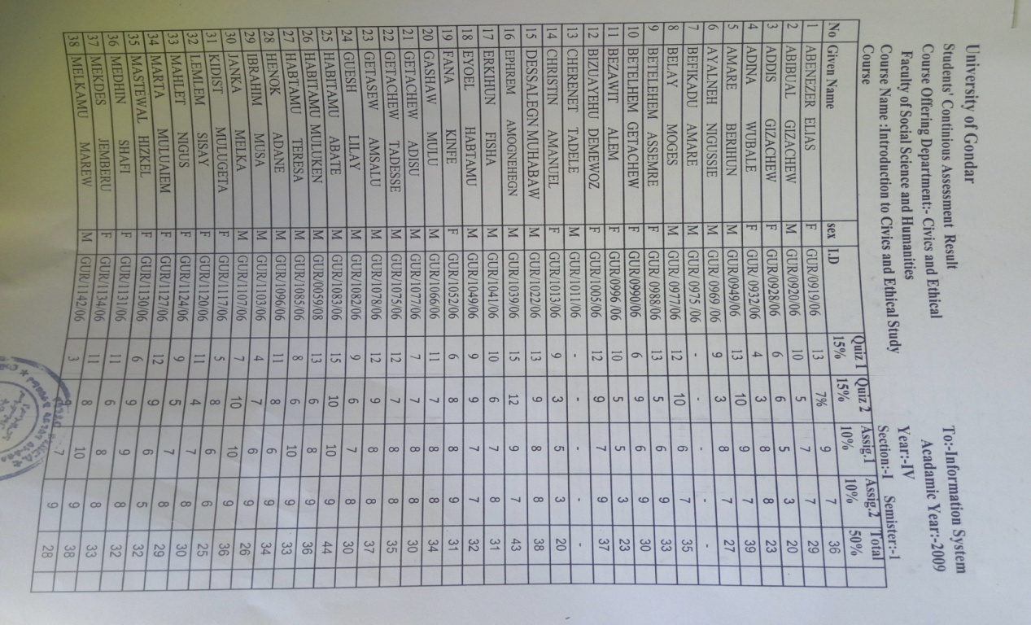

Figure : Student continues assessment result posted on the notice board

# References

[1]. Management Association, I. R. (2010). *Web-Based Education: Concepts, Methodologies, Tools and Applications: Concepts, Methodologies, .* Idea Group Inc (IGI).

[2]. uog. (2010, january 11). *acadamic*. Retrieved ‎November ‎25, 2016, from university of gondar: http://www.uog.edu.et

[3]. Rouse, M. (n.d.). *iterative development*. Retrieved December 25, 2016, from searchsoftwarequality: http://searchsoftwarequality.techtarget.com/definition/iterative-development.

[4]. Grady Booch, G. B. ( (May 29, 2005)). *The Unified Modeling Language User Guide (2nd Edition) 2nd Edition.* Addison-Wesley Professional.

[5]. Vincent Vonk, M. W. (January 14, 2008). *Architecture for an Online Learning System.*

[6]. Al-Omari, M. A. (2010). *e-Learning Management System Using Service Oriented Architecture.* Saudi Arabia: 2010 Science Publications.

[7] .*MOODLE For Teachers, Trainers And Administrators.* (June 1991). USA: Free Software Foundation, Inc.